Major Project

Christy Chan

Sevenoaks School

Table of Contents

[Situation: 2](#_Toc444160242)

[Blood pressure and heart disorders 2](#_Toc444160243)

[Stress: The silent killer 3](#_Toc444160244)

[Hypoxemia and Hypoxia 4](#_Toc444160245)

[Brief 5](#_Toc444160246)

[Potential User Feedback: 5](#_Toc444160247)

[Letter sent out 5](#_Toc444160248)

[Letter from Mrs. S Kasetti 6](#_Toc444160249)

[Letter from Dr. Wai-Chan Chan (my dad) 8](#_Toc444160250)

[Conclusion 8](#_Toc444160251)

[Feasibility and Constraints 8](#_Toc444160252)

[Specifications 9](#_Toc444160253)

[Research 11](#_Toc444160254)

[Primary research, survey 11](#_Toc444160255)

[Types of alarms 12](#_Toc444160256)

[Longest lasting batteries 12](#_Toc444160257)

[Existing Products 14](#_Toc444160258)

[Anthropometrics 16](#_Toc444160259)

[Psychological Properties Of Colours 17](#_Toc444160260)

[Reverse Iontophoresis 19](#_Toc444160261)

[Materials 20](#_Toc444160262)

[Components 20](#_Toc444160263)

[Manufacturing Techniques 21](#_Toc444160264)

[First Ideas - #1 22](#_Toc444160265)

[First Ideas - #2 23](#_Toc444160266)

[First Ideas - #3 24](#_Toc444160267)

[First Ideas - #4 25](#_Toc444160268)

[First Ideas - #5 26](#_Toc444160269)

[First Ideas - #6 27](#_Toc444160270)

[Development 29](#_Toc444160271)

[Product Change 31](#_Toc444160272)

[Casing 37](#_Toc444160273)

[Risk Assessment 39](#_Toc444160274)

[Production Plan 39](#_Toc444160275)

[Circuit Diagram 41](#_Toc444160276)

[Working Drawings 42](#_Toc444160277)

[Evaluation 43](#_Toc444160278)

[Evaluation to Specification 43](#_Toc444160279)

[Personal Evaluation 44](#_Toc444160280)

[External Evaluation 44](#_Toc444160281)

[Appendix 44](#_Toc444160282)

[All Serial Handling 44](#_Toc444160283)

[Interrupt Sequence 46](#_Toc444160284)

[Main Code 49](#_Toc444160285)

# Situation:

## Blood pressure and heart disorders

As of 2013, 67 million American adults (31%) have high blood pressure, and of this only 47% of people with high blood pressure have the condition under control, this meaning that the other 43% are at risk for life-changing diseases. Nearly 33% of the American population has prehypertension – blood pressure that is higher than normal but not yet considered high blood pressure.

From this, more than 348,000 deaths in the US in 2009 had high blood pressure as a primary/contributing cause. Worldwide however, high blood pressure is the primary cause of 7.5 million deaths, about 12.8% of all deaths. [[1]](#footnote-2)Over the course of the past year, this number has not changed much, but compared to previous years, has grown slightly.

|  |  |  |
| --- | --- | --- |
| **Age** | **Men (%)** | **Women (%)** |
| **20-34** | 11.1 | 6.8 |
| **35-44** | 25.1 | 19.0 |
| **45-54** | 37.1 | 35.2 |
| **55-64** | 54.0 | 53.3 |
| **65-74** | 64.0 | 69.3 |
| **75 and older** | 66.7 | 78.5 |
| **All** | 34.1 | 32.7[[2]](#footnote-3) |

* **First heart attack:** About 7 of every 10 people having their first heart attack have high blood pressure.
* **First stroke:** About 8 of every 10 people having their first stroke have high blood pressure.
* **Chronic (long lasting) heart failure:** About 7 of every 10 people with chronic heart failure have high blood pressure.
* **Kidney disease** is also a major risk factor for high blood pressure.[[3]](#footnote-4)If the kidneys do not function, then waste fluids will build up in the body, causing swelling in the ankles, vomiting, and eventually the kidneys will stop working.

Stroke is the 5th cause of death in the U.S.[[4]](#footnote-5)

Heart disease is the leading cause of death in the U.S.[[5]](#footnote-6)

HYPOTENSION

If your blood pressure is slightly low, but do not exhibit side effects of low blood pressure such as a dizziness or seizures, then there is no need to worry. [[6]](#footnote-7)

Heart problems:

Faster, irregular, rapid heartbeats can be symptoms and signs of an oncoming heart attack or coronary artery disease. Palpitations can signify arrhythmias or heart valve disease. All of these add up to the leading cause of deaths in the US.[[7]](#footnote-8)

## Stress: The silent killer

Stress is linked to the six leading causes of death – heart disease, cancer, lung ailments, accidents, cirrhosis of the liver, and suicide. [[8]](#footnote-9)

The body responds to stress and anxiety in the same ways it responds to fear and excitement, by producing adrenaline, activating the “fight or flight” system. At a chemical level, your body releases hormones that make you more alert, focused, energized. This causes increased heart rate and perspiration. [[9]](#footnote-10)

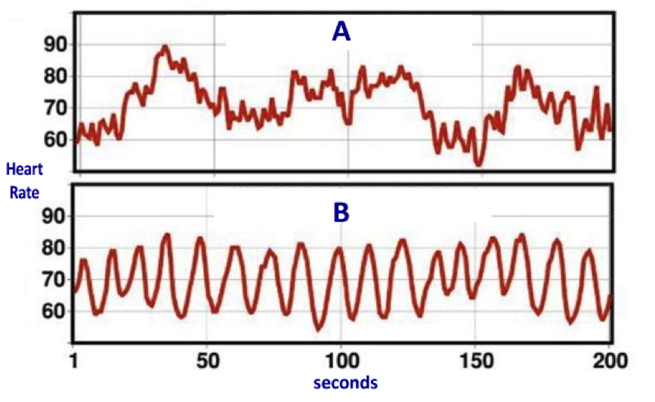[[10]](#footnote-11)

These are graphs of heart rate variability against time. A is when the heart or mind is in chaos, showing that it is like a huge rollercoaster going up and down, and is not coherent. However, in B, the heart and mind are coherent, so the heart rate variability is in coherence. This is due to the sympathetic and parasympathetic nervous systems, in which the sympathetic speeds up the heart rate, and the parasympathetic slows down the heart rate. They both have to work together, so they work alternately. When coherent, they work and form a nice series of waves. [[11]](#footnote-12)

## Hypoxemia and Hypoxia

Hypoxemia is the low level of oxygen in your blood, which may eventually lead to hypoxia. Hypoxia is the low level of oxygen in your tissues, causing symptoms such as rapid breathing, shortness of breath, and changes in color of the skin. This requires immediate medical attention, as you will pass out or die because you will not be able to function normally. [[12]](#footnote-13)

[[13]](#footnote-14)

# Brief

I am going to design, manufacture, test and implement a product that will detect when the user’s blood pressure or heart rate is too high or too low and alert them.

As you can see from my statistics above, this product will be essential because 31% of the American population has high blood pressure, and 43% of these people are at risk for life-changing diseases such as strokes or coronary artery disease. This is in order to prevent the onset of these diseases from becoming too extreme.

## Potential User Feedback:

### Letter sent out

Dear Mrs. Kasetti,

My name is Christy Chan, and I am a student at Sevenoaks School. I am currently doing a project for my Robotics design SSC course. I am planning to design a heart rate and blood pressure monitor that fits around the wrist, which can periodically measure blood pressure and heart rate to detect any problems the patient might have, and alarm them gently if so. I was wondering if you knew anyone who had hypertension or heart disorders, how old they are and what type of job they do, and if that might greatly affect their blood pressure when relaxed.

In addition, I would like to ask what type of alarm you believe would allow for someone to know if their blood pressure was too high, but without causing the patient themselves’ blood pressure to go high.

As well as this, I would like to know more about whether or not there are certain types of fatal diseases that this product could help detect, other than that of hypertension and hypotension, heart murmurs and some other disorders.

If there is any other useful information for me to know about how certain factors would affect blood pressure or the heart, please do not hesitate to let me know. I am very thankful for your time, and I hope to hear from you soon.

Faithfully,

Christy Chan

### Letter from Mrs. S Kasetti

Hi Christy

Your device - a wrist monitor to detect heart rate and blood pressure sounds very interesting.

Pulse is traditionally measured by palpating the radial artery at the wrist. The measurement is accurate, reliable and repeatable. One has to look at both the rate and rhythm in order to get useful information from pulse measurements.

There are a few wrist home monitors avaliable on the market. They are advisable for few patients for home monitoring of BP,  as upper arm BP measurement is more accurate and reliable.

Primary hypertension tends to be a disorder affecting the older population and is multifactorial when one is looking for the cause.

Heart disorders are varied and some can be present from birth.

I am pasting this segment from a journal regarding BP -

Wrist blood pressure monitors can be accurate if used exactly as directed. However, according to the American Heart Association, it's best to use a home blood pressure monitor that measures blood pressure in your upper arm. Devices for the upper arm are also easier to check for accuracy than are wrist monitors.

Wrist blood pressure monitors are extremely sensitive to body position. To get an accurate reading when taking your blood pressure with a wrist monitor, your arm and wrist must be at heart level. Even then, blood pressure measurements taken at the wrist are usually higher and less accurate than those taken at your arm. That's because the wrist arteries are narrower and not as deep under your skin as those of the forearm.

Some people can't have their blood pressure measured at the upper arm because they have a very large arm or find blood pressure measurements painful. In these cases, measuring blood pressure at the wrist is acceptable.

A clip to help with causes for arrythmias -

Arrhythmias may be caused by many different factors, including:

* Coronary artery disease.
* Electrolyte imbalances in your blood (such as sodium or potassium).
* Changes in your heart muscle.
* Injury from a [heart attack](http://www.medicinenet.com/heart_attack/article.htm).
* Healing process after heart surgery.
* Irregular heart rhythms can also occur in "normal, healthy" hearts.

Monitoring is a very useful tool. For detecting, diagnosis and effectiveness of the treatment initiated for the patient.

The subject matter is vast and I have tried to answer the questions you have asked.

As a project for you -

\*The reliability of the measurements;

\*The ease of putting the cuff independently by the patient;

\*Memory feature to store the measured values with time and date;

\*An optional alarm feature like a flickering value - when doctor to be contacted for advice and provision to individualise 'the alarm values' for the patient would be an attractive feature.

Good luck for the project.

Regards

Mrs S Kasetti

Sent from Samsung Mobile

### Letter from Dr. Wai-Chan Chan (my dad)

Hello Daughter

Your idea is a good one and one that is needed by many people

One of my friends has hypertension and needs such a device

Whilst it can strike at any age, it is typically something that strikes later in life and can really affect anyone – in my friends case, he was a management consultant and now works for a private equity firm, jobs that are very stressful which has probably led to his hypertension – he is in his mid 40s

His job is stressful so this impacts his blood pressure

I think simply telling someone through a beep that the blood pressure has been continually higher after several readings is what is needed

I am not sure the device unless you alter it can detect much more;  by applying pressure you can determine blood pressure;  and through pulses can detect the heart rate

Beyond that, I am not sure it can do anymore unless it is light enough where it can be worn all the time and can also measure number of steps taken etc, like Fitbit

Many things impact hypertension:

Diet i.e. Too much salt

Stress, i.e. Too much is bad

Lifestyle, i.e. Too sedentary, too much excitement

For heart disease, these are:

Diet, i.e. Too much fat is bad

Lifestyle, i.e. Lack of exercise

The biggest one is genetics, i.e. If one of your parents, has it, there is a higher chance that the son/daughter will have it

Ask mum if she has the harvard report on the silent killer, hypertension

Let me know if you need more

## Conclusion

As you can see from the highlighted parts above, pulse would be relatively easy to measure and is quick, efficient and reliable, however the blood pressure would be hard to measure normally and regularly, as the person would have to get into the right position so maintain a controlled state.

# Feasibility and Constraints

Safety/Legislation, it will have to comply to EU standards of safety, which will limit how the product will work. It will also take time to comply and complete these, so it will limit how well the product can be.

Cost, I will be working under a budget, where materials will have to be cheap, limiting how many things I can try or buy or 3D print out.

Personal Knowledge, I will be working using my own knowledge, which will limit the quality of the product and how it works.

School Facilities I will be working at school which will affect the facilities I will be able to use.

Time, I will have only a certain amount of time to work in, I will have class lessons and prep times. I lose about 10 minutes in commuting to school facilities so then I

will have less time than expected. There are also exeats and school vacations which will limit the time at school and what I can do at school. I will have to be looking at research which will take up time and it will depend on whether people will answer me.

# **Specifications**

THIS PRODUCT MUST/SHOULD:

1. Be safe for children over the age of 4 because it would be used around children.
2. Withstand normal bumps and scratches as it is in a place that could get hit easily.
3. Fit comfortably as it would be worn for a long period time.
4. Be easy to put on so people would not give up using it.
5. Be easy to set up/install so elderly could use it.
6. Cost less than £50 otherwise it would be too expensive for the target market.
7. Be able to be batch manufactured so it would reduce manufacturing costs.
8. Use a small rechargeable battery so there is no need to replace the battery.
9. Look fashionable so the market would want to wear/buy it.
10. Be available in a range of colors so the market would appeal to it.
11. Have only one discreet button so it is not complicated.
12. Be able to be programmed if needed for repairs.
13. Must look calming to not provoke the user and stress them out.

|  |  |  |  |
| --- | --- | --- | --- |
| Priorities of research | Primary research | Secondary research | Progress |
| 1 | Existing products at a shop, Currys | Which? (tests all products) http://www.which.co.uk/ | Done |
| 2 | Longest lasting batteries (from smartphones or other products) asking around people with phones, photographs | Google search on rechargable batteries, number of cycles, how long the battery will last, how to recharge | Done |
| 3 | How to make it, pull apart a watch, photographs of the inside of the watch | How to make a watch, place electronics in the watch, backlight. | Done |
| 4 | Ask people who they know have hbp problems | Google search on people who die because of high blood pressure, hospital statistics | Done |
| 5 | Marketing, how to sell the product (ask Dad, product sellers | Sales process on iDEA. | Done |
| 6 | Safety standards | British + EU safety standards in a book | Done |
| 7 | Polls on most relaxing colors, size, thickness, market research, ask tech teachers on how to create this | Best relaxing colors, pitch of alarm, font size, weight, size of avg wrist, thickness, button size, packaging, etc. | Done |
| 8 | Shock proof design and structure, pick apart a watch, ask Uncle Carlos | How to shockproof a watch, how many feet, etc. | Done |
| 9 | Which materials are easy to clean, types of materials in hospitals | Cleanest types of materials, hospital medical grade materials, non conductive materials | Done |
| 10 | Arduino, sizes of arduino | google search on sizes of arduino boards | Done |
| 11 | Packaging, manufacturing boxes, walking around a shop | Box suppliers, types of box, look of box | Done |
| 12 | Types of alarms | When to alarm the person, how to code this | Done |
| 13 | Location of the blood pressure monitor, best ways of measuring this (from hospitals, etc.) | Nurses handbook on where to place blood pressure ring | Done |
| 14 | How to load the information into a computer, experiments, ask as doctors. | Software doctors use, how to load info onto the software. | Done |
| 15 | What is reverse iontophresis, take a glucowatch and figure out how it works | Google search/ask doctors on how the the Bpro ABPM works | Done |
| 16 | Ask tech teachers on how to create a circuit | google search on circuitry, and how to create a circuit | Done |

# Research

**Existing products/location of blood pressure monitor:**

Polar FT 2 Watch tracks your latest workout, has simple one button functionality, and has an age based target heart rate zone.[[14]](#footnote-15)

Polar FT4 Watch has all the same as the FT2, but has an additional zone pointer to help you exercise at the right intensity. [[15]](#footnote-16)

Now a new wireless monitor from [Hewlett-Packard](http://www.hp.com/) and a Singapore company called [Healthstats](http://www.healthstats.com/en/bpro-intro.html" \t "_blank) aims to make it much easier for patients and doctors to monitor blood pressure. The device, which has the size and look of a wristwatch, can monitor pressure continuously—which provides a much more accurate picture than infrequent readings in the doctor’s office. Until now, the only way to do such continuous monitoring has been with a cumbersome inflatable cuff for the arm or wrist.

Unlike standard equipment, the Healthstats device relies on a sensor that rests against an artery in the wrist and detects the shape of the pressure wave as blood flows through it.  (The device is first calibrated with a standard blood pressure monitor.)[[16]](#footnote-17)

From the highlighted parts above, you can see that the technology to constantly measure blood pressure using a small object is already there. This product is called the BPro abpm (ambulatory blood pressure monitor) patient monitor wrist watch. It measures the blood pressure through the radial artery.

## Primary research, survey

People affected by high blood pressure:

Upon taking a survey, these are the following results.

Fish- yes, 60yrs, retired family history

Pragna – yes, 50 yrs, orthopaedic surgeon no family history

Andrew- yes, 51 yrs, banker, family history

Agnes – yes 50 yrs, management consultant, has family history

## Types of alarms

***Chime Clocks****: These*[*quiet, old-fashioned clocks*](http://giftaroo.com/Merchant2/merchant.mv?Screen=PROD&Store_Code=GiftBox&Product_Code=LM-3101H)*move the sleeper into wakefulness with a softer sound than an alarm buzzer.* [[17]](#footnote-18)

From the excerpt above, I have concluded that because this alarm tells you when your blood pressure is too high, if you have an alarm buzzer, it will further aggravate your blood pressure, so that is not a good idea, as the main purpose of this product is to tell you to lower your blood pressure. By using an iconic chime, the patient will know when their blood pressure is too high but will not be startled when it happens.

## Longest lasting batteries

Ideally, a battery will offer a balance of the following:

* Long duration
* High performance
* Fair cost
* Environmental friendliness

Among rechargeables, Nickel Metal Hydride (NiMH) are tops. They typically can be recharged and reused 150 to 500+ times. They outperform single-use batteries in "high-drain" devices. They require fairly regular maintenance. They grow less predictable as they age.

**Precharged NiMH**

Also called "hybrid," "ready-to-use" or "low self-discharge" batteries, this NiMH battery comes precharged in its package so it's ready for action. It offers a very low self-discharge rate (power loss when not in use), which makes it best-of-breed in the rechargeable category for cylindrical batteries (AA, AAA, C and D cells).

**Volts:** 1.2 (steady voltage is generally sustained throughout a cycle).

**Estimated number of recharging cycles:** 150 to 500, maybe more.

**Self-discharge rate:** Much better than standard NiMH batteries, roughly 10% to 20% over 6 months.

**Maintenance:** If left unused, should be recharged every 6 to 9 months. Benefits by being used frequently.

**Lithium-ion**

They're not yet widely available in the cylindrical shape of AA, AAA, C or D batteries, but battery insiders say they are on the horizon. Lithium-ion batteries today are more commonly found in the form of a slab, block or battery-pack. They are used extensively in mobile phones, single-reflex digital cameras, computers, camcorders and other consumer electronics.

**Volts:** 3.6 (with some variations).

**Estimated number of recharging cycles:** 500 to 1,000+.

**Self-discharge rate:** Very low, but age is the enemy of Li-ion batteries. Even if unused, the simple passage of time robs them of some energy capacity. The quantity of the loss varies according to the size and configuration of the battery.[[18]](#footnote-19)

As you can see from highlighted text above, batteries need to be able to be used for long durations, have high performance, fair cost, and be environmentally friendly. The NiMH is apparently very good, and can be used for long periods of time in ‘high drain’ devices. However, the hybrid NiMH is precharged, meaning that the target market (who are technologically not very advanced) can wear them first try and to test it out. Lithium-ion batteries will die out as time moves on, so the product will not be able to last long. This means that this product will die out, but the product should be able to be kept for at least a year, as the target market will not want to buy much. Therefore, I believe that the best type of battery for this type of product is the hybrid NiMH, as it suits the target market and the battery does not die out very quickly.

**Recharging a NiMH hybrid battery:**

*NiMH Charging*

*Basics*

NiCad and NiMH batteries are amongst the hardest batteries to charge accurately. Whereas with lithium ion and lead acid batteries you can control overcharge by just setting a maximum charge voltage, the nickel based batteries don't have a "float charge" voltage. So the charging is based on forcing current through the battery. The voltage to do this is not fixed in stone like it is for the other batteries.

*Overnight Charging*

The cheapest way to charge a nickel metal hydride battery is to charge at C/10 or below (10% of the rated capacity per hour). So a 100 mAH battery would be charged at 10 mA for 15 hours. This method does not require an end-of-charge sensor and ensures a full charge. Modern cells have an oxygen recycling catalyst which prevents damage to the battery on overcharge, but this recycling cannot keep up if the charge rate is over C/10.

To preserve battery life the best practice is to use a timer to prevent overcharging to continue past 13 to 15 hours.

*Fastest Charging*

If a temperature monitor is used NiMH batteries can be charged at rates up to 1C (in other words 100% of the battery capacity in amp-hours for 1.5 hours).[[19]](#footnote-20)

As you can see from the highlighted text above, NiMH batteries are quite hard to charge accurately, so a charger that charges both slowly and quickly depending on which mode the consumer sets it to. Overnight charging would preserve the life of the battery, however if the consumer uses the fast charging mode it would charge much faster but it will reduce the longevity of the battery.

* Approximately **62,000 unnecessary deaths** from stroke and heart attacks occur due to poor blood pressure control
* High blood pressure **rarely has any symptoms**, the only way for people to know if they have the condition is to have their blood pressure measured
* Approximately **one third** of people with high blood pressure **do not know that they have it**. [[20]](#footnote-21)

From this data you can see that there is a large number of unnecessary deaths due to high blood pressure.

## Existing Products

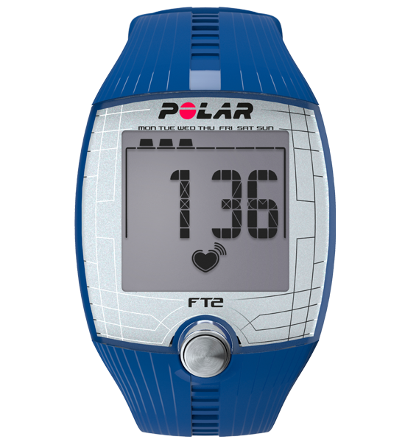[[21]](#footnote-22)Name: Polar FT2 Watch

Cost: £55.50 (4/10)

Rating: 4/10

Ergonomics: 6/10

Aesthetics: 5/10

Specifications:

* Helps improve fitness with automatic aged-based heart rate target zone
* Displays a summary of latest workout

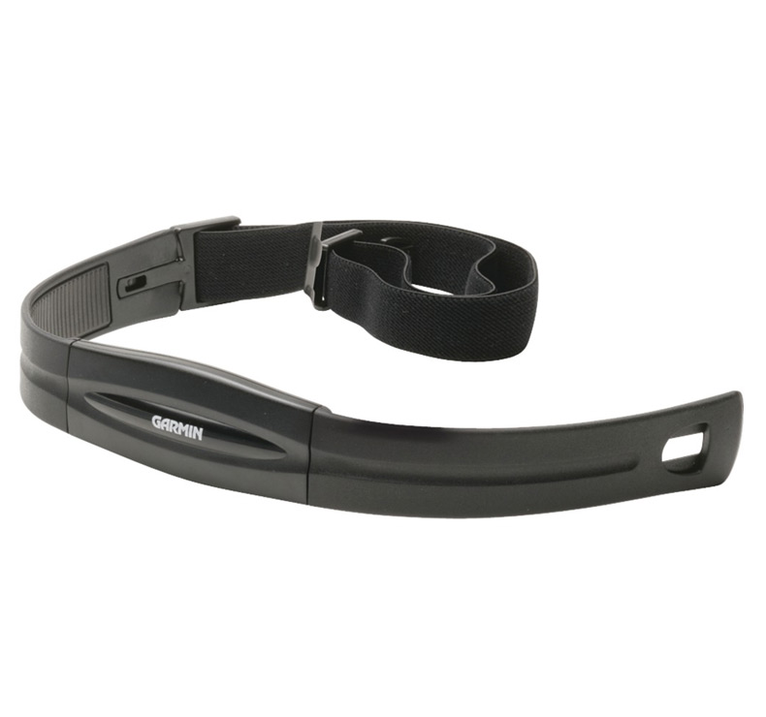[[22]](#footnote-23)Name: Garmin heart rate monitor

Cost: £39.40 (7/10)

Rating: 5/10

Ergonomics: 4/10

Aesthetics: 6/10

Specifications:

* The front contains the Heart Rate module and is made of flexible plastic.
* Once it's paired with your compatible device the first time, it will automatically recognise it each time.
* The fabric of the strap can be removed and hand-washed as often as needed.

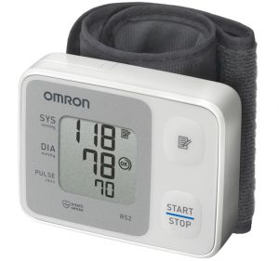

[[23]](#footnote-24) Name: Omron RS2 Wrist Digital Blood Pressure Monitor

Cost: £35.99 (7/10)

Rating: 6/10

Ergonomics: 8/10

Aesthetics: 4/10

Specifications:

* Pre-formed, easy-to-fit cuff ensures that it can be easily worn
* shows irregular heartbeat, hypertension and an icon to indicate correct wrapping.

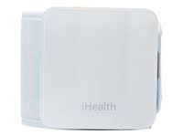

[[24]](#footnote-25) Name: iHealth BP7

Cost: £44 (5/10)

Rating: 5/10

Ergonomics: 6/10

Aesthetics: 7/10

Specifications:

* Motion Sensor Technology helps ensure accurate readings
* Measures pressure directly from apple product

[[25]](#footnote-26)Name: BPro Wrist AMBP monitor

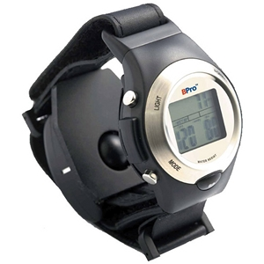Cost: £1200 (1/10)

Rating: 6/10

Ergonomics: 6/10

Aesthetics: 7/10

Specifications:

* Clear LCD display that displays time as well
* Lightweight and easy to use
* Securely fits against the radial artery
* Does not disturb daily activities

[[26]](#footnote-27)Name: Panasonic EW3039 Wrist Blood Pressure Monitor

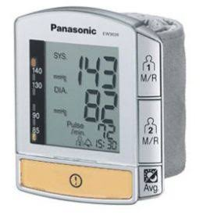Cost: £53 (4/10)

Rating: 7/10

Ergonomics: 7/10

Aesthetics: 6/10

Specifications:

* Arrhythmia & irregular pulse warning indicator
* 3-colour signal light display for blood pressure classification according to the WHO standard
* High pressure warning: reading flashes

Conclusion:

These products above are top of the market, and the strengths are that they can connect to mobile phones.

## Anthropometrics

* Measurements of the human body DATA (height, length, ability to see, reach envelope)
* Wrist sizes, finger sizes

|  |  |
| --- | --- |
| **Adult Petite** | 7 ins. |
| **Adult Small** | 7.25 ins. |
| **Adult Medium** | 7.5 ins. |
| **Adult Large** | 7.75 ins. |
| **Adult XLarge** | 8 ins.[[27]](#footnote-28) |

|  |  |  |  |  |
| --- | --- | --- | --- | --- |
| **Hand breadth** | **Male** | 78 | 87 | 95 |
| **Female** | 69 | 76 | 83-85[[28]](#footnote-29) |

* Includes physiological (lifting certain weights) and psychological (whether they like textures, taste, smell)
* Using anthropometric data to design the product around, so the product will fit the large part of the market.

Anthropometrics will affect my design because as well as having to fit around the wrists of small and large people (5th and 95th percentiles).

Biomechanics

* Ergonomics based on position of human or product (screwing things in) (position on wrist)

Biomechanics will affect my design because if the button is on a different side to the person’s dominant hand, it will be hard to press the button. What people will feel will be different as the blood pressure is measured, so biomechanically I have to change it so it feels comfortable for many people.

Physiological –

* Will this affect the growth of the wrist? Will it damage the wrist or blood flow through the wrist?.
* I do not believe it will because it will be loose fitting and take measurements periodically.

Psychological- will people use this product if it was dark and scary looking?

## Psychological Properties Of Colours

|  |  |
| --- | --- |
|  | |
| **RED.** Physical Positive: Physical courage, strength, warmth, energy, basic survival, 'fight or flight', stimulation, masculinity, excitement.  Negative: Defiance, aggression, visual impact, strain. |  |
| **BLUE.** Intellectual. Positive: Intelligence, communication, trust, efficiency, serenity, duty, logic, coolness, reflection, calm. Negative: Coldness, aloofness, lack of emotion, unfriendliness. |  |
| **YELLOW.** Emotional Positive: Optimism, confidence, self-esteem, extraversion, emotional strength, friendliness, creativity.  Negative: Irrationality, fear, emotional fragility, depression, anxiety, suicide. |  |
| **GREEN.** Balance Positive: Harmony, balance, refreshment, universal love, rest, restoration, reassurance, environmental awareness, equilibrium, peace.  Negative: Boredom, stagnation, blandness, enervation. |  |
| **VIOLET.** Spiritual Positive: Spiritual awareness, containment, vision, luxury, authenticity, truth, quality.  Negative: Introversion, decadence, suppression, inferiority. |  |
| **ORANGE.** Positive: Physical comfort, food, warmth, security, sensuality, passion, abundance, fun.  Negative: Deprivation, frustration, frivolity, immaturity. |  |
| **PINK.** Positive: Physical tranquillity, nurture, warmth, femininity, love, sexuality, survival of the species.  Negative: Inhibition, emotional claustrophobia, emasculation, physical weakness. |  |
| **GREY.** Positive: Psychological neutrality.  Negative: Lack of confidence, dampness, depression, hibernation, lack of energy. |  |
| **BLACK.** Positive: Sophistication, glamour, security, emotional safety, efficiency, substance.  Negative: Oppression, coldness, menace, heaviness. |  |
| **WHITE.** Positive: Hygiene, sterility, clarity, purity, cleanness, simplicity, sophistication, efficiency.  Negative: Sterility, coldness, barriers, unfriendliness, elitism. |  |
| **BROWN.** Positive: Seriousness, warmth, Nature, earthiness, reliability, support.  Negative: Lack of humour, heaviness, lack of sophistication. | [[29]](#footnote-30) |

Psychologically, different colors make people feel different ways. For example, if the product was a fierce red, then it would possibly make people’s blood pressure go higher, as it is a sign of anger and violence. Blue is a calming color, but represent coldness and unfriendliness. Green however is a peaceful color, where it represents harmony and balance, but the negative impact of it is boredom.

## Reverse Iontophoresis

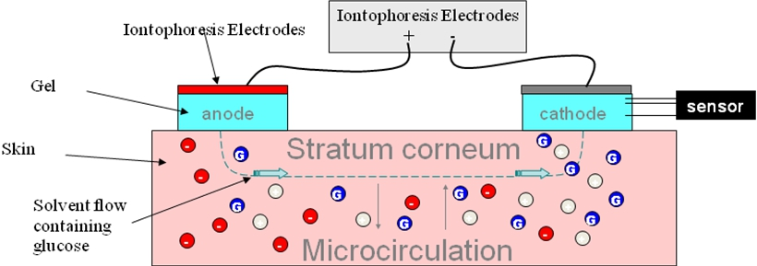[[30]](#footnote-31)

What went wrong with the GlucoWatch?

Using the GlucoWatch was a somewhat arduous project for some patients. The device required a three-hour warm up period and had to be calibrated with a finger stick measurement. Many users were dismayed because using the device still required frequent pin pricks.

After calibration, the GlucoWatch then sent a low-level electrical current through a users' body which pulled fluid through the skin. Electrodes in the device then monitored blood sugar levels. Some patients found this process very uncomfortable, even painful. Many reported skin irritation.

A randomized study from researchers at the University College of London pointed out further shortcomings with the GlucoWatch device. Their results were published in the May 2009 edition of the journal Diabetic Medicine. Though only 6 percent were unable to tolerate wearing the device, participants noted inaccuracies in their readings on the GlucoWatch G2 Biographer. Another clinical study from the Stanford School of Medicine found that the GlucoWatch frequently triggered false alarms, erroneously telling users their blood sugar was two high. Out of 20 alarms sounded, only 10 cases actually correctly assessed a too-high reading, the other 10 were false positives.

Now GlucoWatch has vanished from the diabetes care scene and its manufacturer has stopped any further development.[[31]](#footnote-32)

As you can see from the highlighted text above, I did some research into measuring blood glucose without having to poke your finger out of interest as to whether I could add this to my project, but the technology has not reached that point yet and so I will not be able to combine this into my project.

## Materials

Plastics

Two types of plastics – Thermosetting and Thermoplastic

Thermoplastics:

Can be heated and shaped over and over again, when heated are pliable but when cooled gain rigidity.

Examples: ABS, HIPS, PVC

Thermosetting:

Can also be shaped, but once set they do not change even if heat is applied again.

Do not need to be cooled down to gain rigidity.

Examples: Urea Formaldehyde, Melamine Formaldehyde[[32]](#footnote-33)

## Components

Components that might be needed are:

**Pulse Sensor**

There already come pre-made from pulsesensor.com and they have full on setup guides as well as troubleshooting.

There are no other pre-made ones, and buying LEDs as well as an LDR will be a large hassle, when there are some prefabricated. [[33]](#footnote-34)

**Arduino (preferably a small size)**

There are many different sizes for the Arduino, the Nano, Pro Mini, Uno, Due, Micro, etc.

These all have different specifications:

The Nano has a Mini B USB cable, and its dimensions are 45x18 mm.

Pulse is recorded as analogue data, so it will need an analogue port.

The Uno is a standard entry level product, but it is too big to fit around the wrist.

The Pro Mini has the same dimensions as the Nano, but does not have a USB cable. It has more analogue ports than the Nano, and also provides I2C support, which will be used in the LED Matrix or LCD Screen.[[34]](#footnote-35)

**LED Matrix or LCD Screen**

Can be bought by themselves, but some can be bought with a backpack to reduce the amount of coding needed and setup required.

The backpack requires the Arduino to have I2C support.

Adafruit provides these at a price, but they have forums and other troubleshooting tips, so I have chosen them to buy their 0.8” mini LED Matrix with I2C Backpack, in green so it is not a disturbing color.

## Manufacturing Techniques

For plastics these can include:

**Vacuum forming**

This involves heating a piece of thermoplastic over a vacuum chamber which holds the pattern. The mould is raised into the plastic sheet, and the air is sucked out. The product has to be designed with a draft angle so the pattern can be released from the final piece.

**Injection Moulding**

Plastic granules are fed into an Archimedean screw, which is heated and held in a cavity as the screw is moved backwards. The plastic is then forced into the mould, which is fast and effective, making complex shapes.

**Extrusion**

Plastic is extruded through a die, and is a continuous process and must have the same cross-sectional area. [[35]](#footnote-36)

In conclusion, I will choose to use a thermoplastic, preferably PVC as it is flexible and can come in different colors, which is a specification in my product. In addition, I will be injection moulding the piece I am creating and it is simple and effective and can make complex shapes, and is the safest bet for my potential designs.

Buying list:

LED Matrix from Adafruit, Pure Green 0.8” Mini

Pulse sensor from pulsesensor.com

Arduino Pro Mini

PVC (potentially)

Small sized coin-cell battery (CR 2032)

# https://www.adafruit.com/images/1200x900/1374-00.jpgFirst Ideas - #1



Blue color for calming effect, green for balance, yellow for optimism

Arrows pointing up and down with LEDs that indicate whether it is too high or low

Arrows will cause discomfort and push into skin

Looks fashionable

No loose parts, safe for kids over 4

Made out of a comfortable silicone, it is easy to put on

Silicone means can withstand bumps

Small rechargeable battery for easy use

One discreet capacitive touch button at the back, so when you take it off, it turns off

No need for setup/install, put it on, and it calculates average to detect normal and abnormal.

The capacitive sensor at the back might look like this

In conclusion: This is slightly unrealistic, as blood pressure cuffs do not come in that small of a size, however, if it was larger (larger wrist cuff), it would fit more comfortably, because the arrows would be in the cuff, and it would work as a blood pressure cuff. The silicone might not work, as it cannot expand a lot and at large degrees, so won’t be able to fit the cuff. [[36]](#footnote-37)

## First Ideas - #2

Made out of a lightweight metal, eg titanium, so looks fashionable

Looks calming, no provocative colors

One discreet button on the screen—swipe to activate

LED screen that shows blood pressure and heart rate and time

Opens at the back for USB programming and charging

Fits comfortably, no digging edges

Lightweight metal can also withstand bumps and scratches

Small rechargeable li-ion battery implanted behind screen

Easy set-up – input age and weight and you’re all set

Easy to put on due to opening at the back

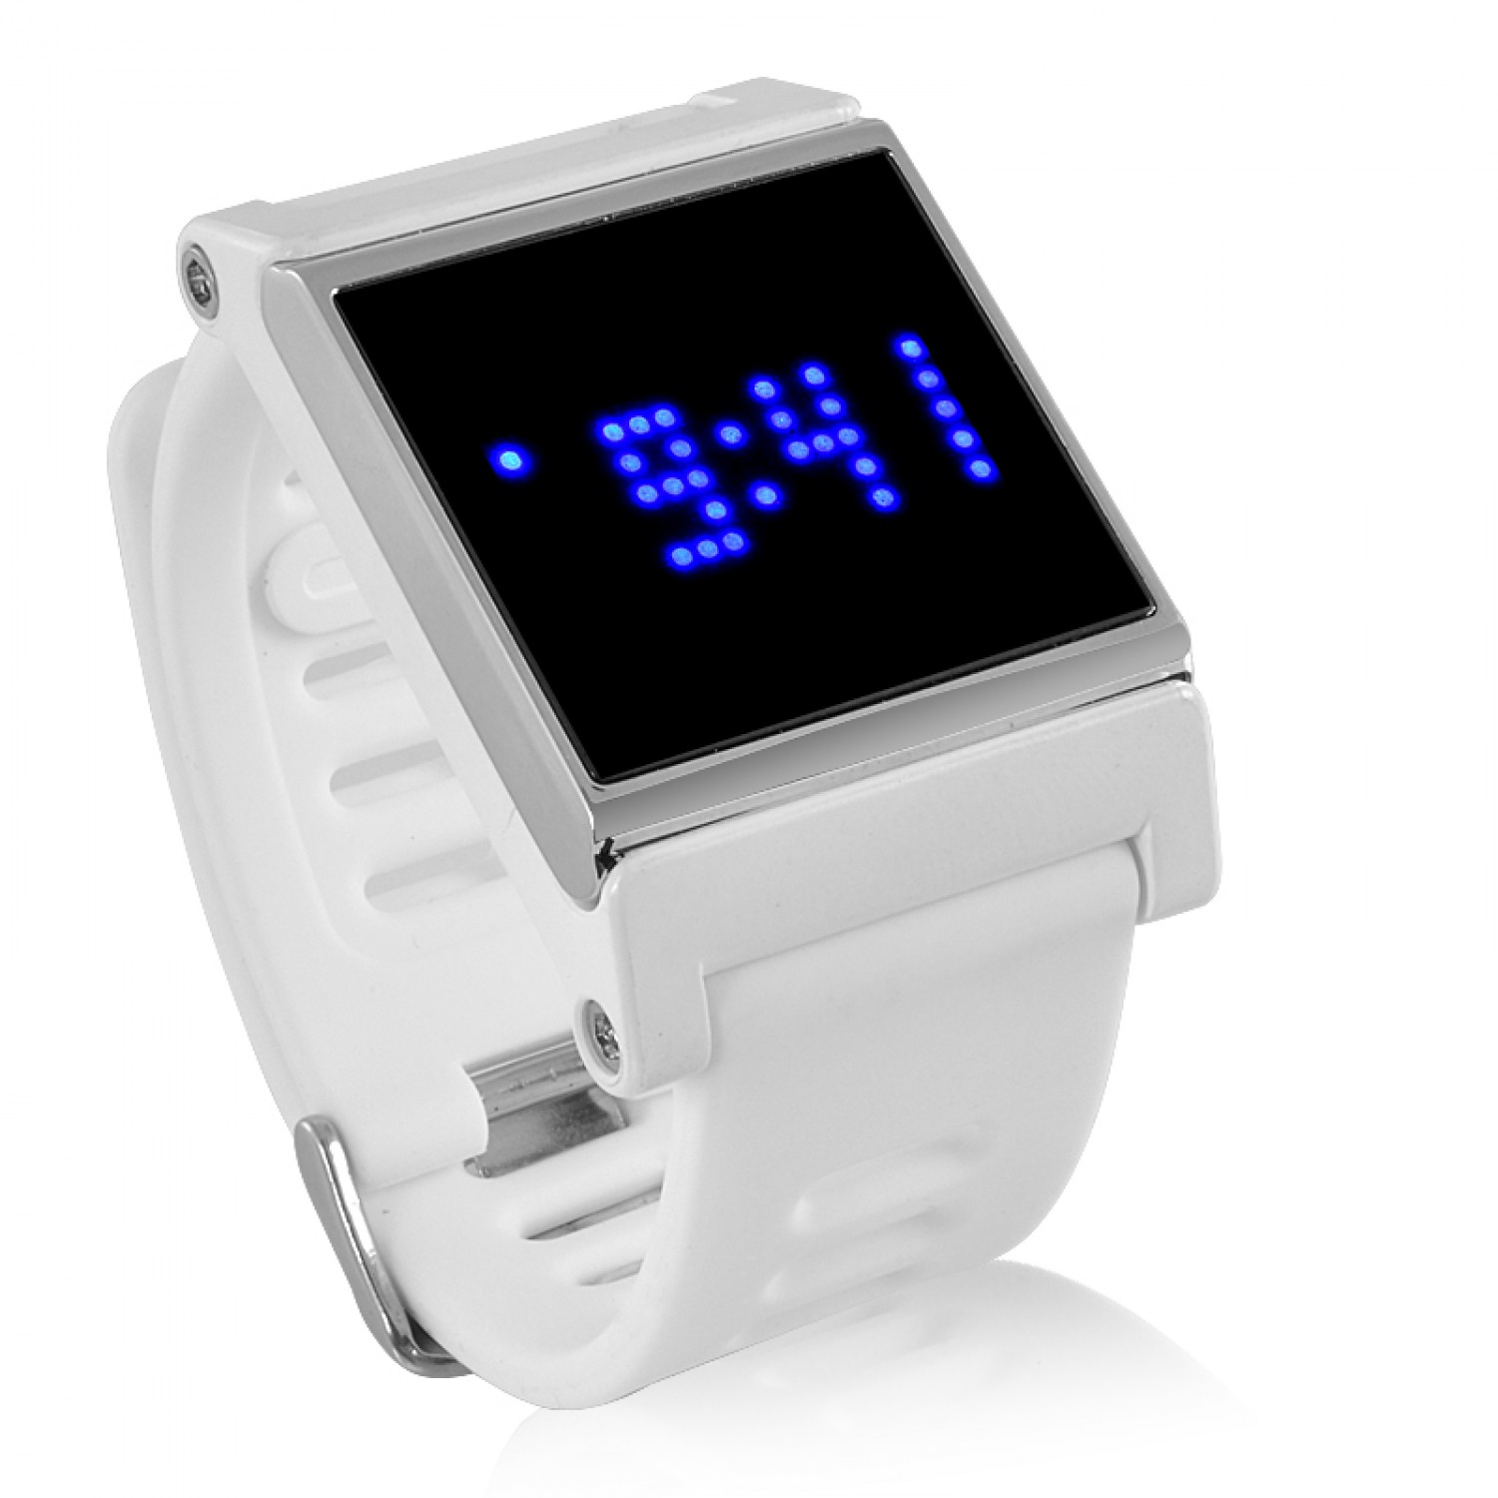

Possible LED screen style

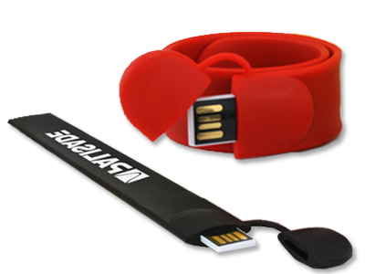

Condensed USB size like this

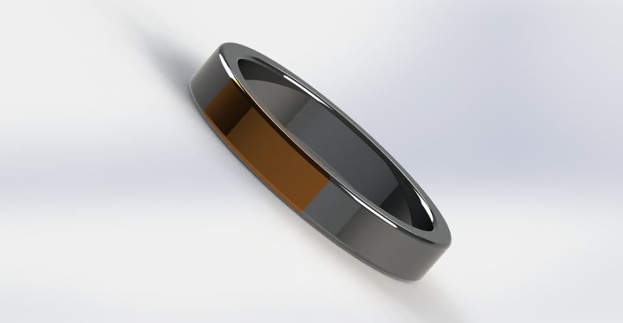[[37]](#footnote-38)

[[38]](#footnote-39)

In conclusion: This idea is quite realistic, however, it has not placed the idea of the blood pressure cuff inside it, so it would look very different. The metal cannot expand, so will probably not be able to fit around the expanding cuff. It would probably be like a bangle, and not a tight fit, which would cause some problems for the blood pressure monitor.

## First Ideas - #3

Large cuff to place blood pressure monitor in

Made out of soft, stretchy fabric, eg cotton for comfort

Stretchy for easy put on

One small on/ off button

5 different coloured LEDs to tell if the blood pressure is very high, high, ok, low, very low.

Green colour which is easy on the eyes

Rechargeable battery inside the cuff

Easy setup, no need for input, just turn on and go

Stretchy fabric enables cuff to withstand bumps and scratches

Micro USB port for programming

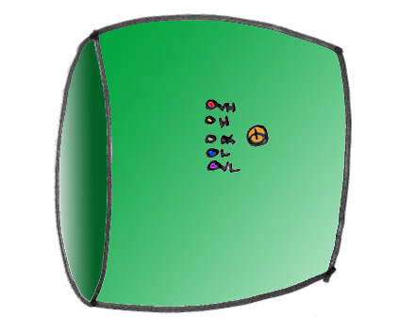

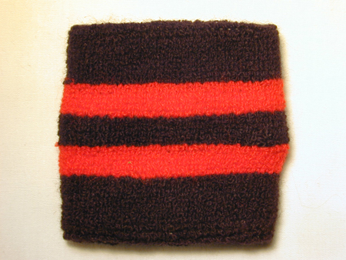[[39]](#footnote-40)

This kind of material

In conclusion: This kind of sweatband-like cuff is very useful and realistic, however, the box in which the electronic components would go into would be very uncomfortable and keep pressing into the skin. The LEDs are simplistic, but they might not tell enough information.

## First Ideas - #4

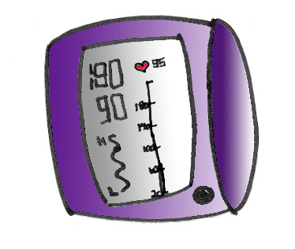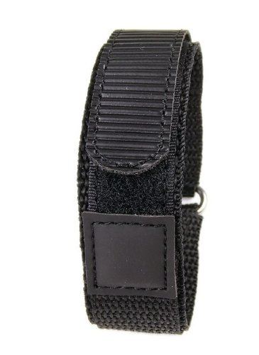

Large LCD screen to display blood pressure and heart rate

Soft stretchy fabric, eg dri-fit polyester for comfort

Small adjustable opening at the back for different sizes, easier to put on

Purple for calming, relaxation

One small on/off button

Press and hold the button to input age and weight for setup

Wifi function to sync to mobile phone, and from there can be programmed

Small rechargeable coin size battery at the back

Lining around screen to protect it from bumps and scratches

Large, round cuff to place monitor in

Adjustable Velcro backing example

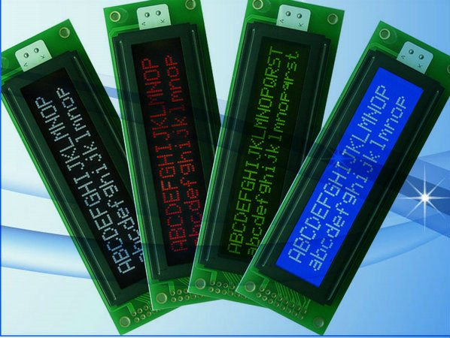[[40]](#footnote-41)

LCD screens like this

In conclusion, this kind of wrist blood pressure monitor is very useful, however it is very much like the ones already in the market, and in order to create something different, it would not be like this. The dri-fit polyester fabric would be very useful, as it is likely to get out into the rain or be placed in a humid environment, meaning it would be easy to dry.

## First Ideas - #5

[[41]](#footnote-42)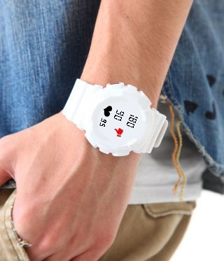[[42]](#footnote-43)

White for cleanliness and sterility

Watch-like LCD screen for familiarity

Adjustable watch backing for easy put on

Thumbs up or thumbs down for good or bad

PVC watch strap to withstand bumps and scratches

Small button on the side

PVC plastic for comfort and softness

Setup only requires age

Small rechargeable battery in the back

Safe for children over 4, no loose parts

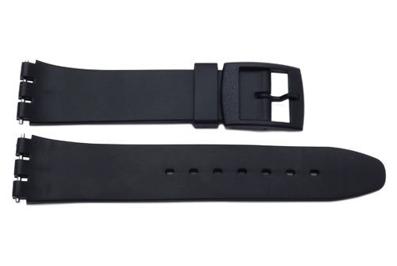

Watch straps like this

In conclusion, this idea can be realistic, however, putting in the blood pressure cuff will prove difficult. It will also not be so loose on the wrist otherwise it won’t be able to measure blood pressure accurately. If it has a watch function, it can be both a blood pressure monitor and watch.

## First Ideas - #6

Attached to phone case, so not permanently around wrist causing discomfort

Heart shaped case to remind user that it is a monitor

One discreet capacitive touch sensor for easy on/off

soft stretchy cotton for outside comfort

Velcro strap for easy put on

Can withstand bumps and scratches due to the plastic nature of the case

No screen – connected directly to phone via NFC which displays data on an app

Easy step by step setup through app

No need for extra battery – uses phone power

Detachable wrist strap so the strap doesn’t hang around

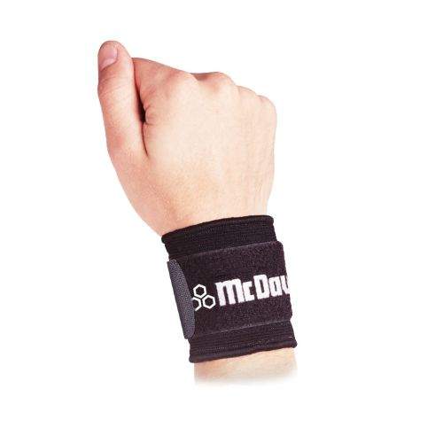

Velcro wrist straps like this

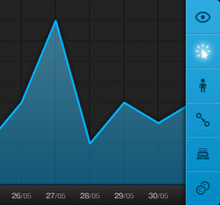

Inside of app may look like this, showing dates and etc.

[[43]](#footnote-44)[[44]](#footnote-45)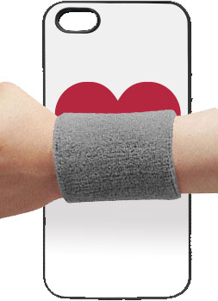[[45]](#footnote-46)

In conclusion: This product is sort of realistic, however the case would be a bit chunky to carry around. It would require a lot of programming to work with an app, and to design an app, so it would be very work-intensive. The Velcro strap makes it able to fit different people, so it can be for families or people who are undergoing weight loss.



# Development

Ergonomics – wrist sizes around the world, adjustable strap lengths

Range of most women’s wrists is from 140mm to 175mm circumference

Men’s is from 165mm to 195mm circumference

However this does not include the apple watch face, which is 38 mm or 42 mm. [[46]](#footnote-47)

Therefore, make 2 straps, one that is 165 mm long, and one that is 195 mm long, the excess can go back around the loop, and have a watch-like face.

Sketch:

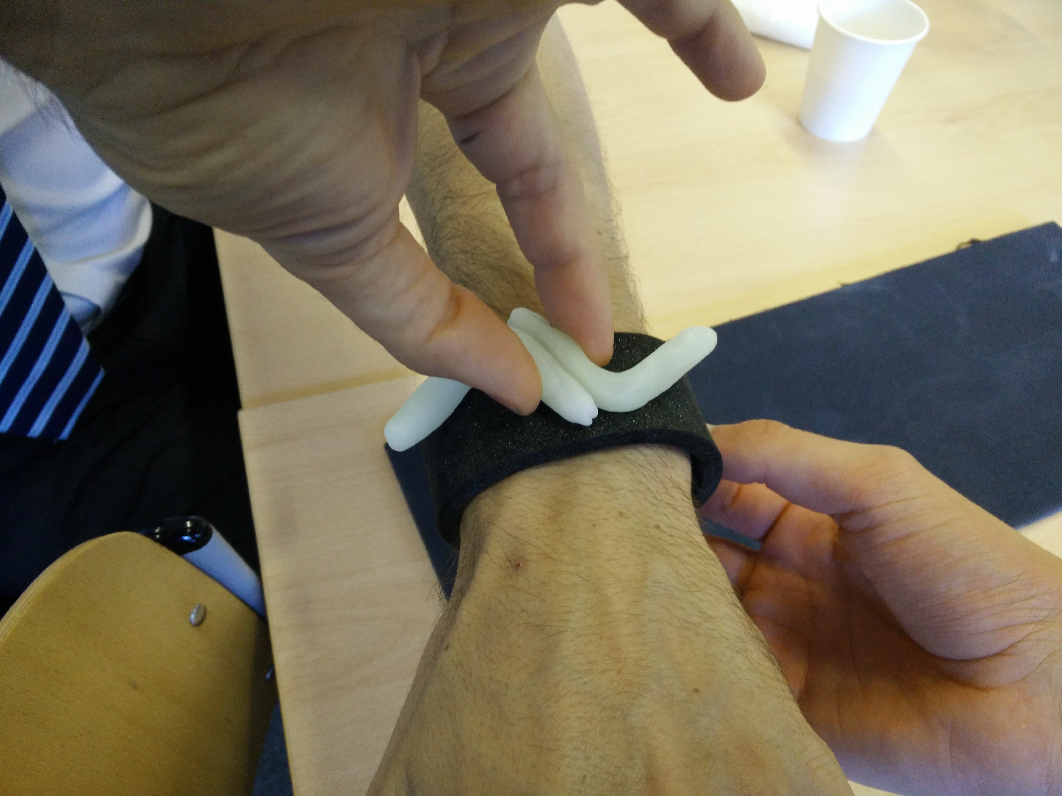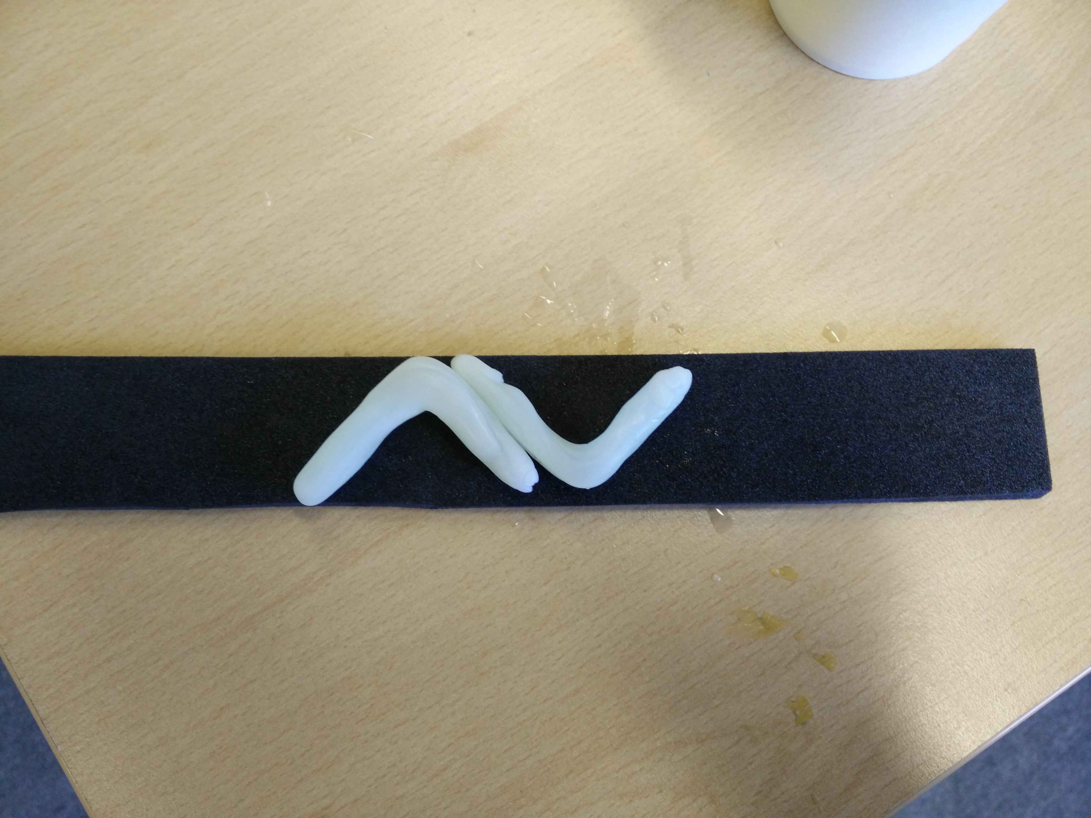Neoprene + Polymorph Model

The arrows were of size 55mm x 30 mm each, so together they were 90mm x 30 mm. Thickness was of 10 mm.

Watch strap was of 260mm length.

Problems/Evaluation:

The arrows will stick out and poke things – make them smaller but thicker, or put them as two up and down arrows with the ends touching each other.

The watch strap was a bit too long – try cutting it down to about 230-240 mm in length.

How to make the pulse component:

Pulse sensor from Proto-Pic.

How to make the blood pressure measuring component:

<http://www.instructables.com/id/Automated-Blood-Pressure-Cuff-Arduino-Project/?ALLSTEPS>

<http://www.instructables.com/id/Blood-Pressure-Monitor/?ALLSTEPS>

From these two websites, the components I will need are, apart from the Arduino:

* Blood pressure cuff (wrist)
* Pressure sensor <http://proto-pic.co.uk/barometric-pressure-sensor-bmp180-breakout/>
* A voltage controlled valve
* Air pump
* Resistors
* Capacitors
* Plastic tubing
* A 3 way splitter

Silicone wrist strap

Mold , pour the liquid silicone into the mold.

– Velcro (available at school)

## Product Change

**Instead of making a blood pressure monitor, I will choose to make a pulse monitor related to stress. This is due to the fact that stress is also a leading cause of death, and in order to take care of someone’s mental health and well-being, heart rate can be monitored to monitor the kind of lifestyle the person is having and how much stress they have. This means that the pulse monitor can form a graph of heart rate variability, to notify the user whether he is in a mental state of chaos (stressed) or is coherent.**

<http://pulsesensor.com/pages/pulse-sensor-amped-arduino-v1dot1>

Investigating the heart rate variability (over time) when emotions change:

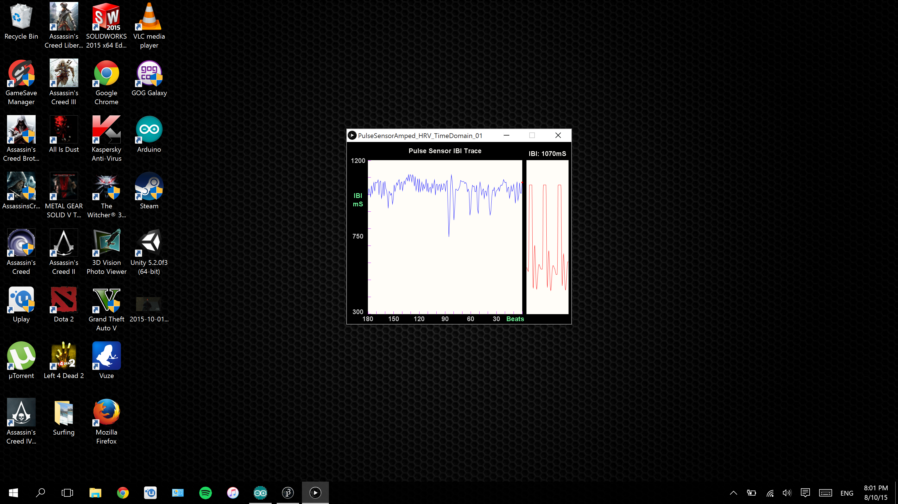This is a visualization of the raw pulse sensor information. On the left, and 180 to 90 beats ago, the pulse sensor’s IBI (inter beat interval) was a fairly constant up and down motion. This is when I was calm, but as I started to get stressed, at around 90 beats ago to the most recent one, the line started becoming less even, more jagged and more chaotic.

Emotions changed my heart rate variability as you can see from the graph.

As I wanted to alert the user when their mental health was in a state of chaos, I decided to use a discreet vibrate, to not let anyone else except the person themselves. So I had to investigate the heart rate variability (over time) and how vibrations affected it.

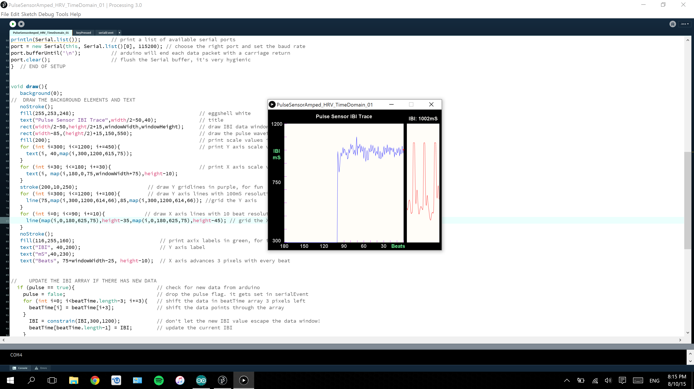

(I tried to stay at the same level of emotion throughout the testing.)

As you can see from the graph, from 90-50 beats ago I was measuring my heart rate variability as per normal. From 50 beats until the most recent one, I applied a continuous on/off vibration (like a message that kept getting received on a phone) on my phone next to my wrist (the test area). It made no different to the heart rate variability, so it is safe to say that vibration does not affect HRV.

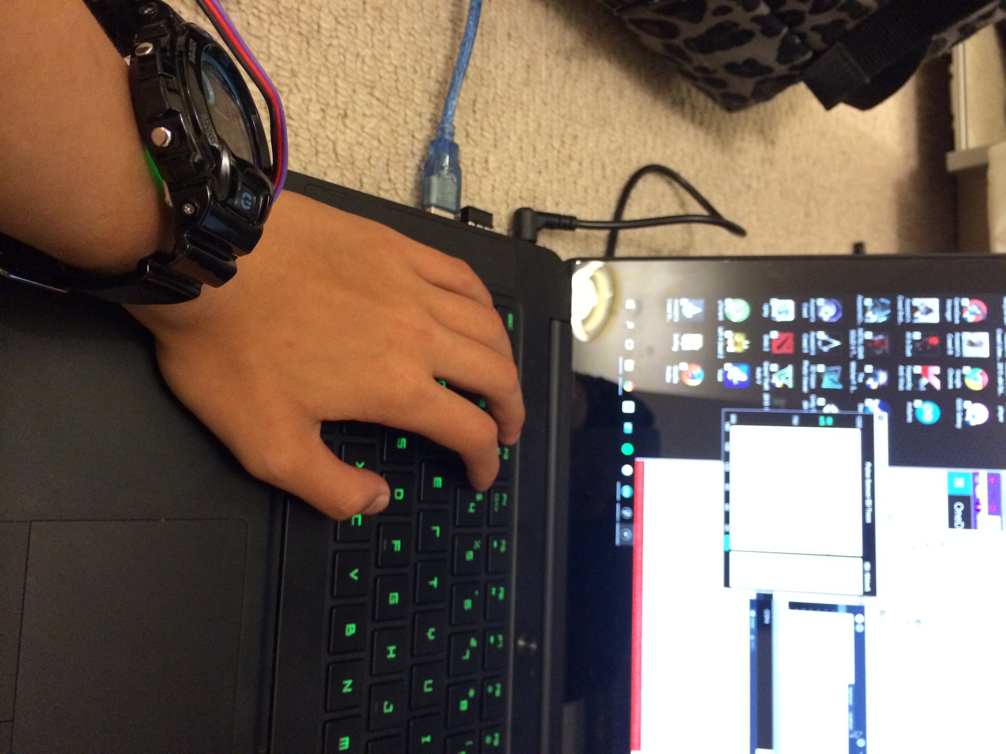

Photo of me testing it (the sensor is under my watch so it can stay in the same place)

Coding:

In the code above, when the difference between the most recent inter beat interval and the last inter beat interval is less than -90, turns the LED, name EmoLite, on.

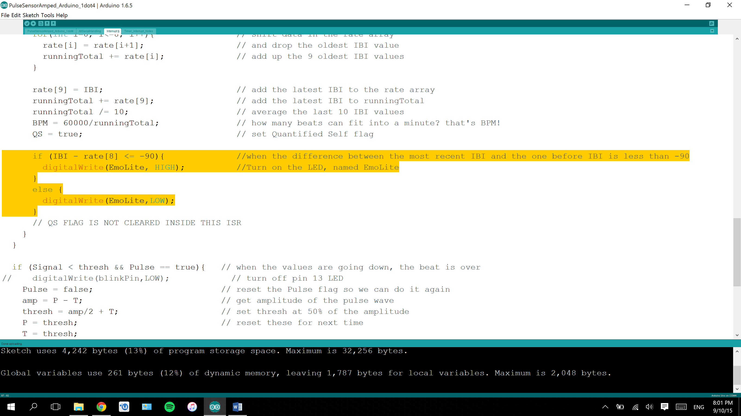Then, to make sure it happened 3 times over 20 seconds, I put 3 if/else statements into each other, and I also realized it was in the ISR (the Interrupt Sequence part of the program) and I had put delays in it so that wasn’t feasible. So I moved it out into the main code, and changed rate[8] to PBI which stands for Previous Beat Interval. I declared it as a volatile variable at the start and made sure it was assigned a value at exactly the same time rate[8] was too.

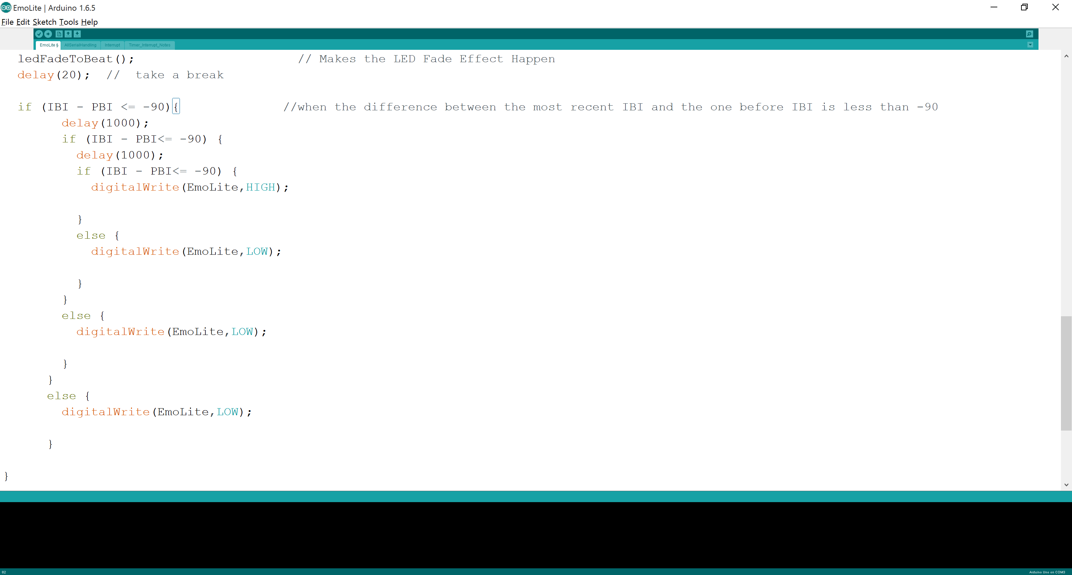

Figuring out the LED Matrix.

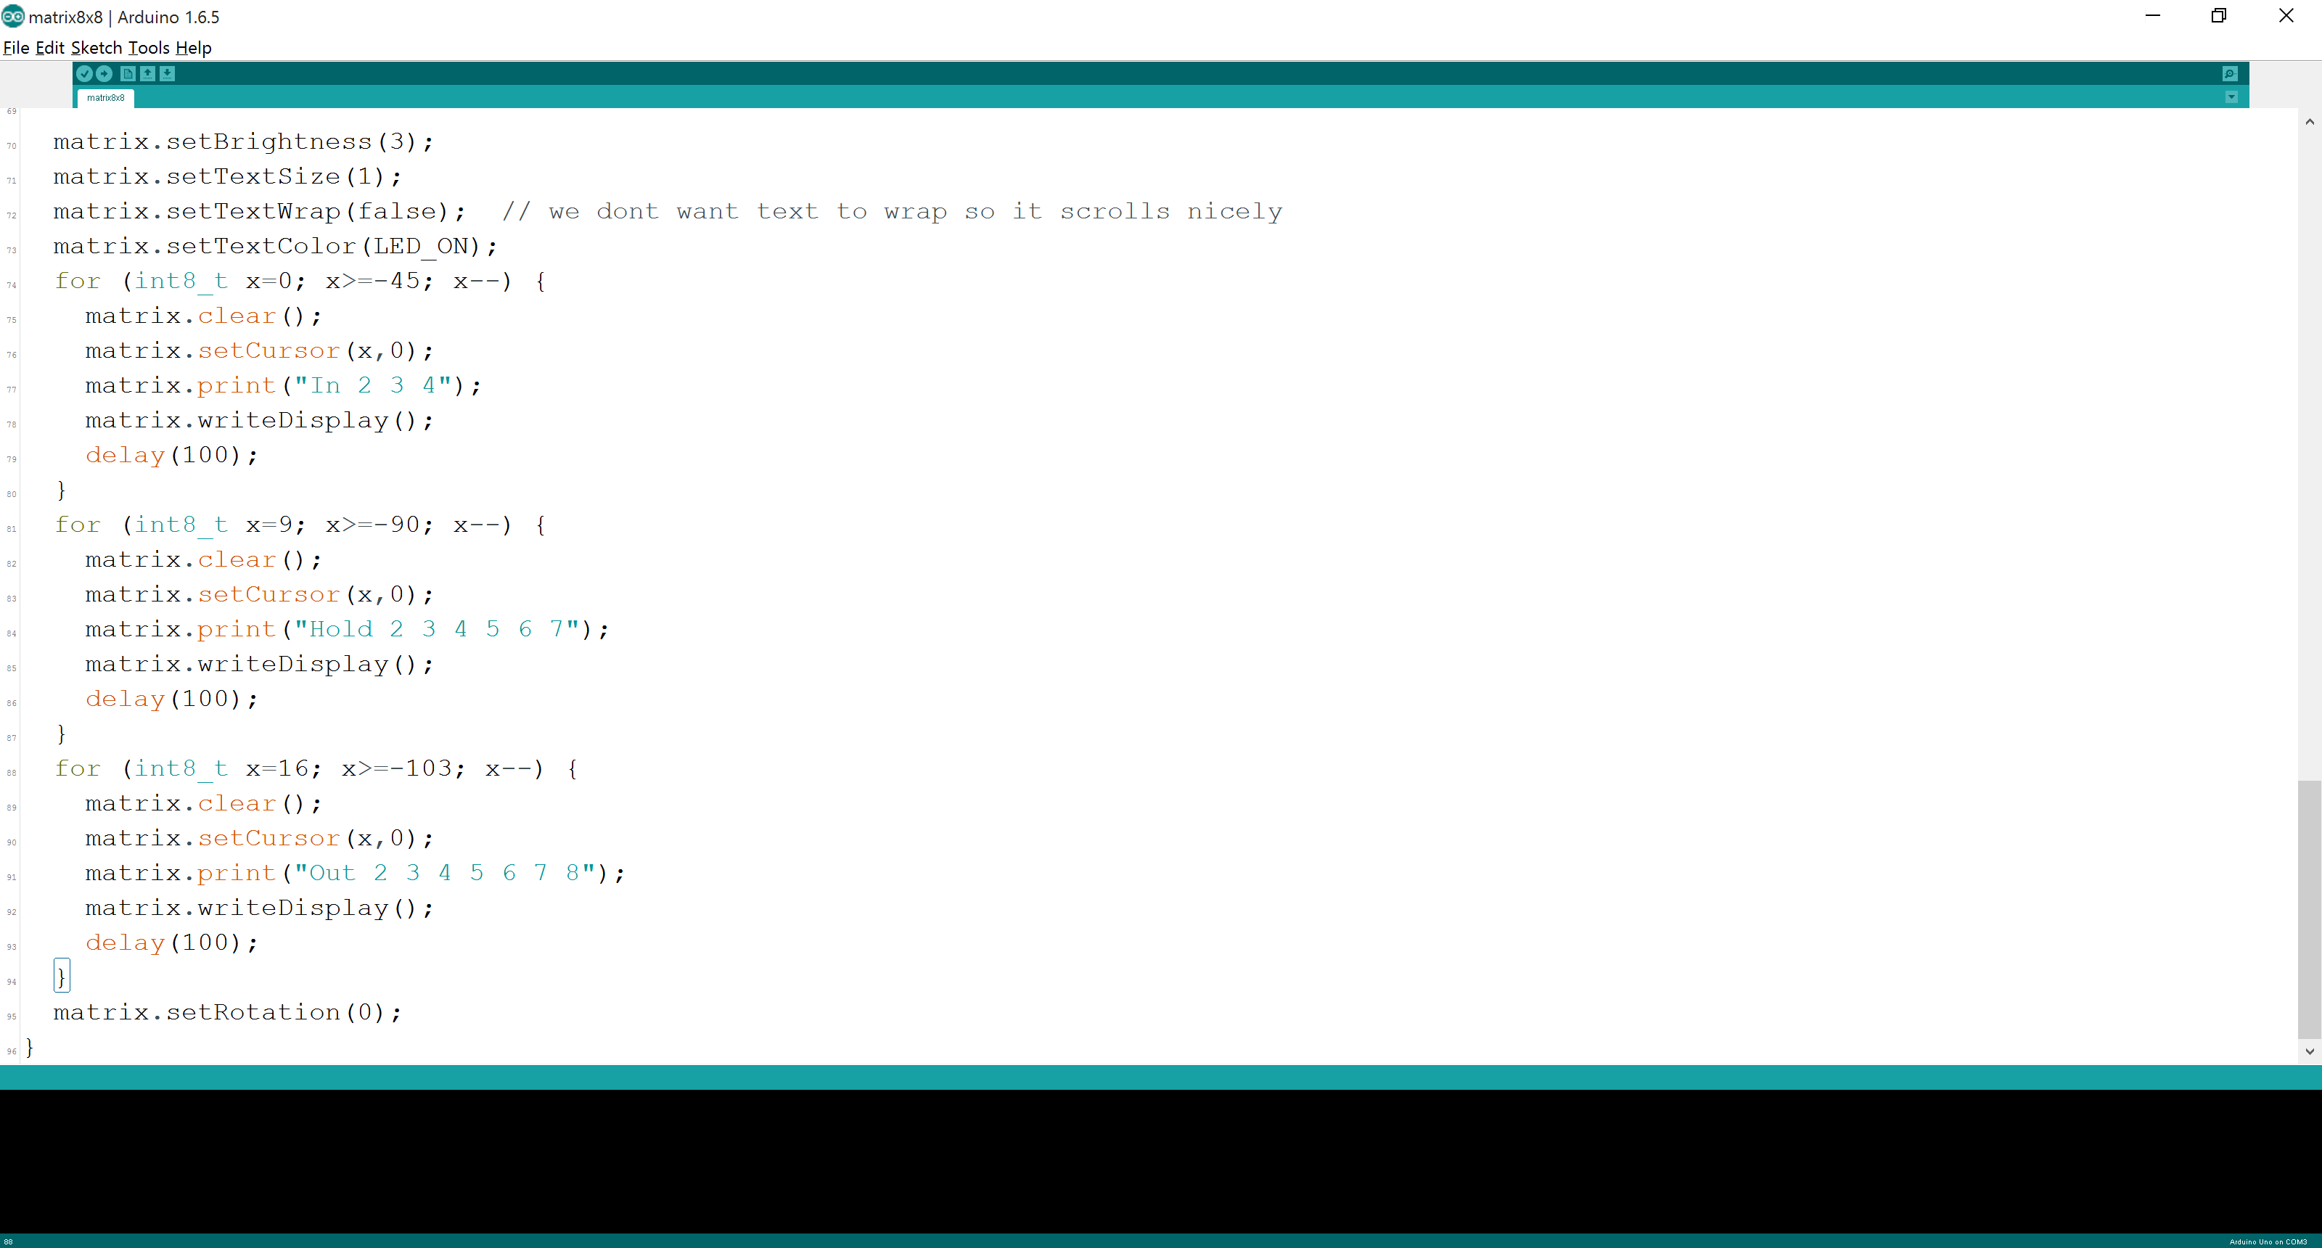

I turned the LED Matrix on, and input the code. It gave me a smile and a whole bunch of shapes and some text. I changed the text to say In 2 3 4, Hold 2 3 4 5 6 7, and Out 2 3 4 5 6 7 8. Deleted all the other shapes except for the smiley face, and uploaded it. Sometimes it paused or didn’t finish the text in time for the next one to begin, as it scrolled nicely through the text, so I changed the x numbers and through the process of trial and error, I made sure the text finished before the next one continued.

Through the power of online Arduino forums, I ensured that the matrix would do the same thing as the EmoLite would, but instead print out the words In, 2, 3, 4 followed by Hold 2 3 4 5 6 7 and Out 2 3 4 5 6 7 8. This a demonstration of the 478 breathing technique, in which you breathe in for 4 counts, hold it for 7, and out for 8. [[47]](#footnote-48)

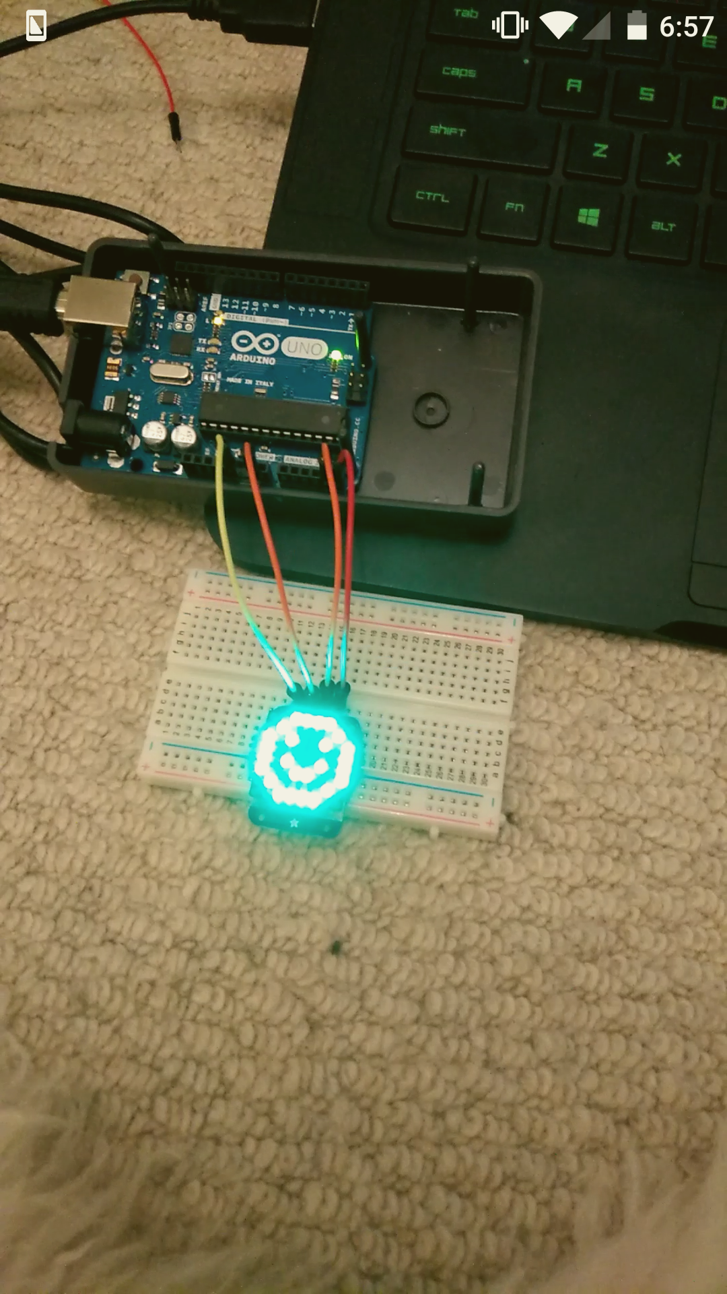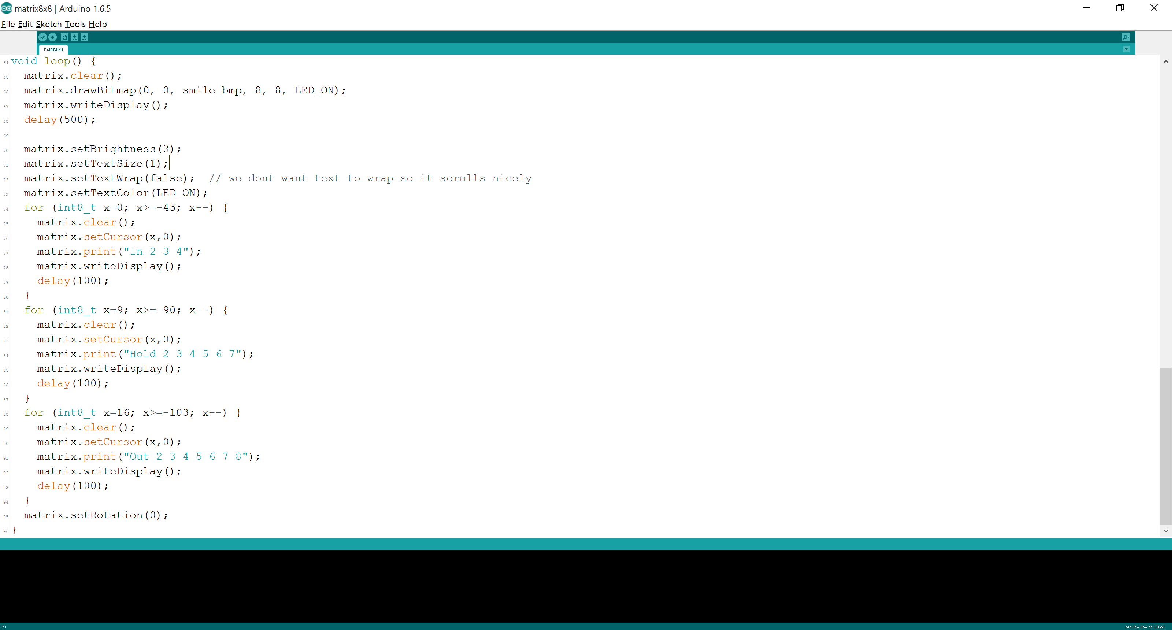

Merged the files together, resolved any compliance issues using the power of Arduino forums:

<https://forum.arduino.cc/index.php?topic=364309.0>

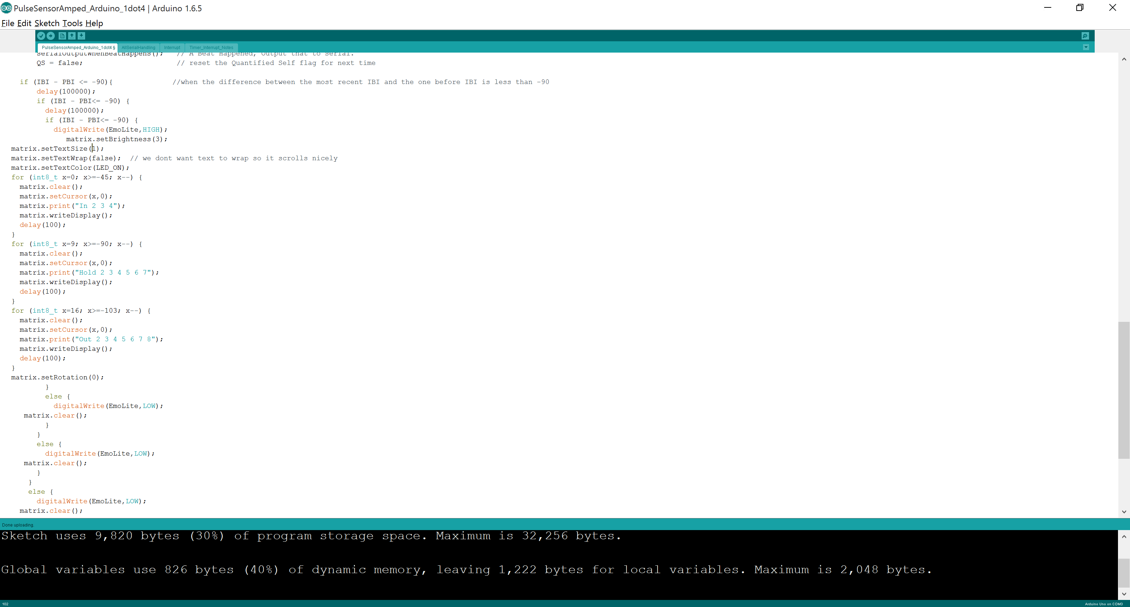

The only problem so far, was that when a pulse was not detected by the Arduino pulse sensor, it would immediately stop sending serial data, which would then set off the LED Matrix sequence to tell me to breathe. However, other than that problem, it works perfectly well.

[Link to Arduino code file](#_Appendix)

Sketch of wristband style:

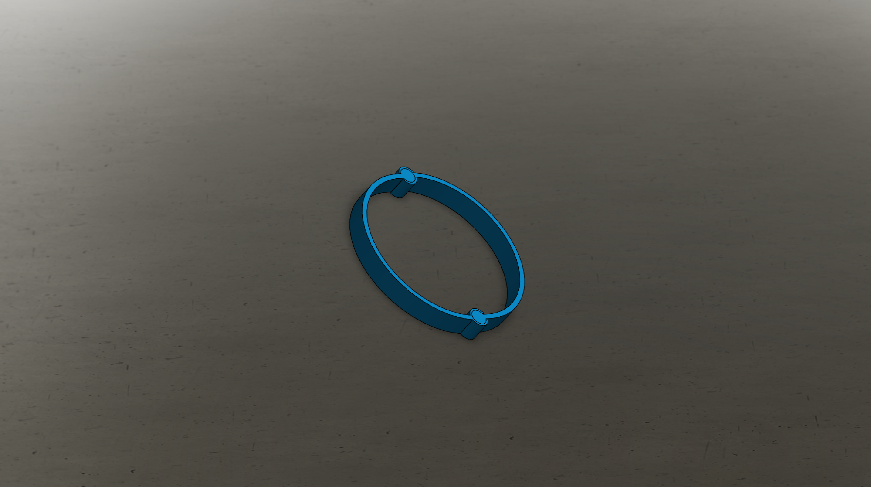

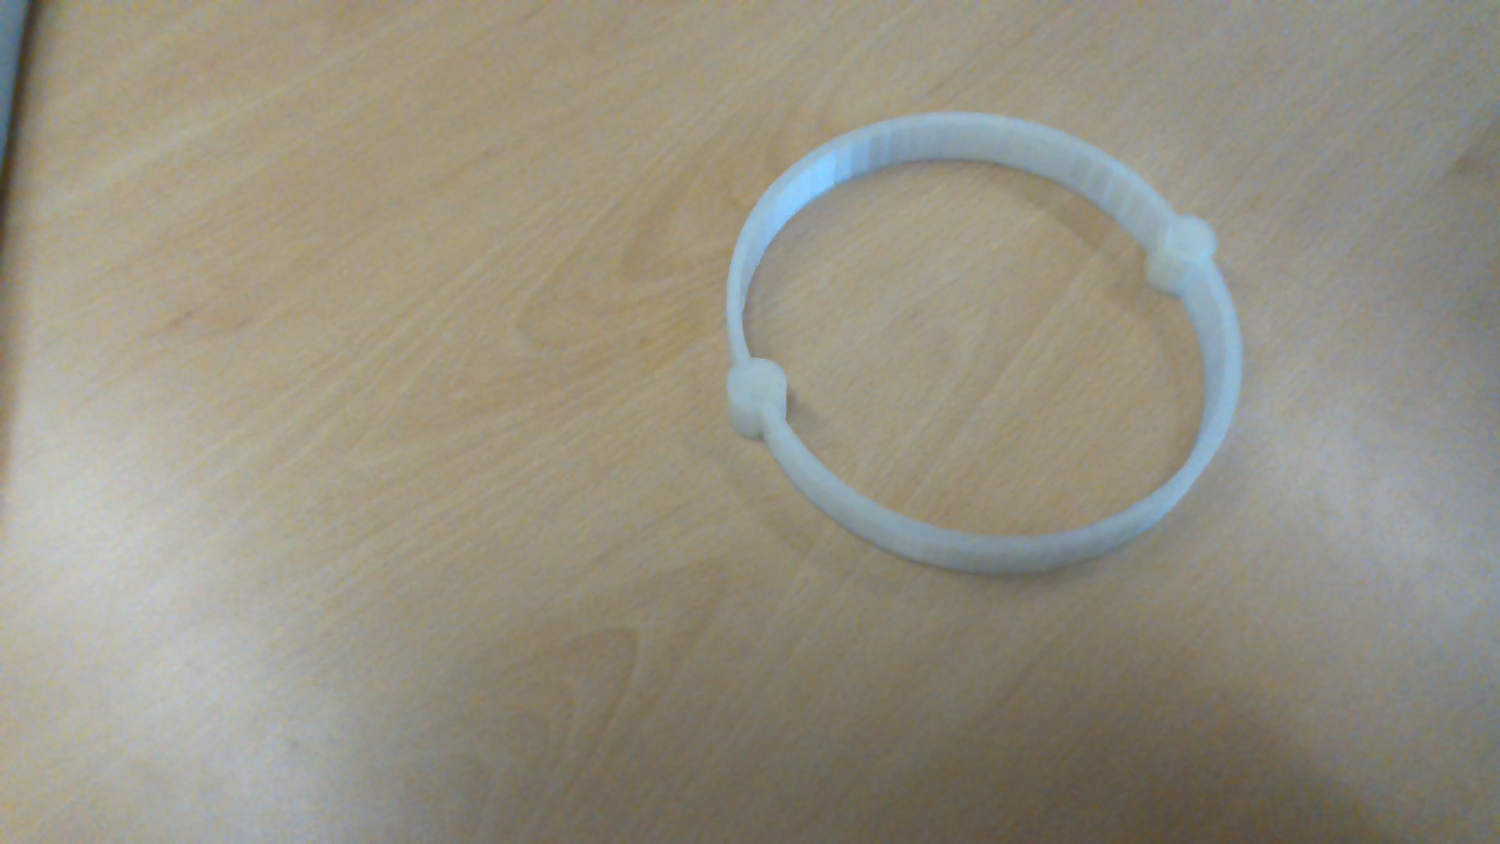Real life model:

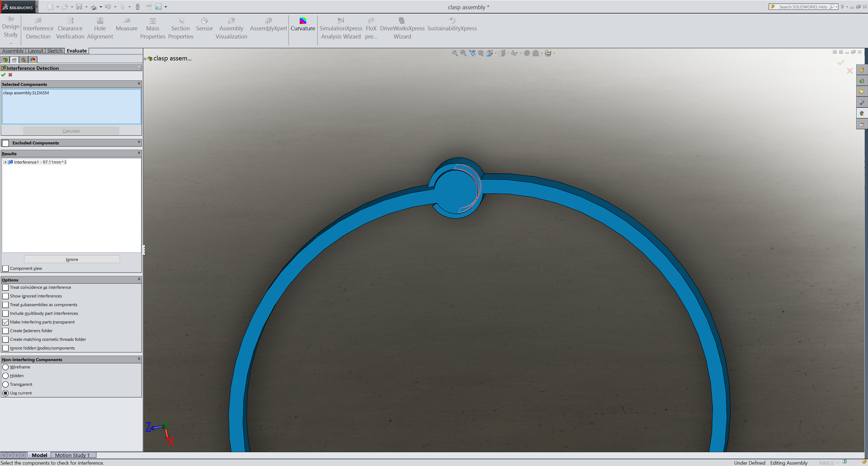Evaluation: The wristband came out huge, it could fit around my leg. I mistook circumference for radius for some reason, and as I sketched the whole thing on solidworks relative to each other, everything was in the right proportions but it was just too big. In addition, the circles (when I fit it around my leg) that acted as clasps were too bulky and dug into the skin, so I resolved to just have a flexible single non-detachable wristband, of the right size of the wrist. I also didn’t factor in the fact that I had to have the electronic component casing to fit the Arduino, pulse sensor, etc. so the size of the spindles would have to be smaller to enable more movement. One good thing was the spindles fit perfectly around the circles, as shown using Solidworks’ interference evaluation:

Ditched that idea, moved on and figured a one piece flexible wristband would be better, here is the sketch:

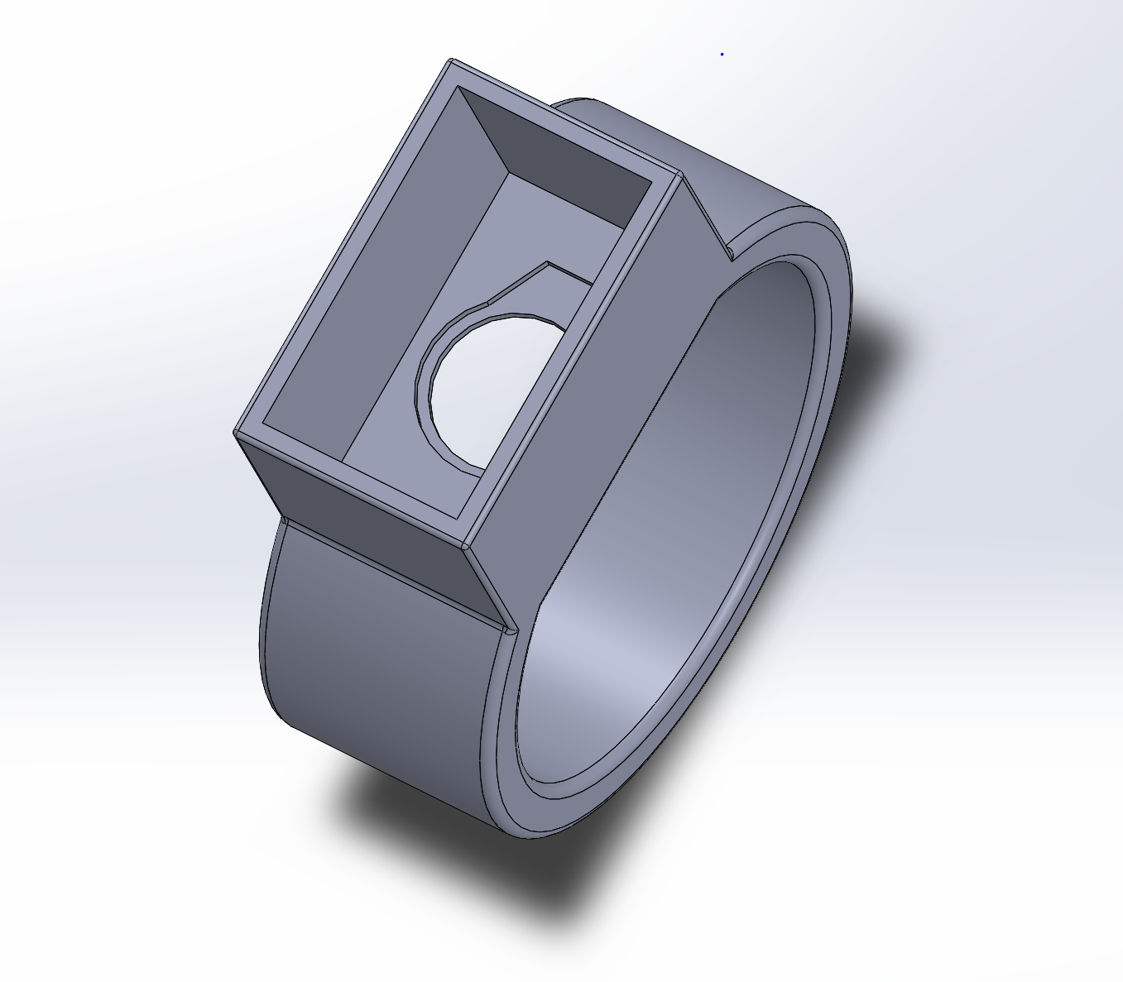

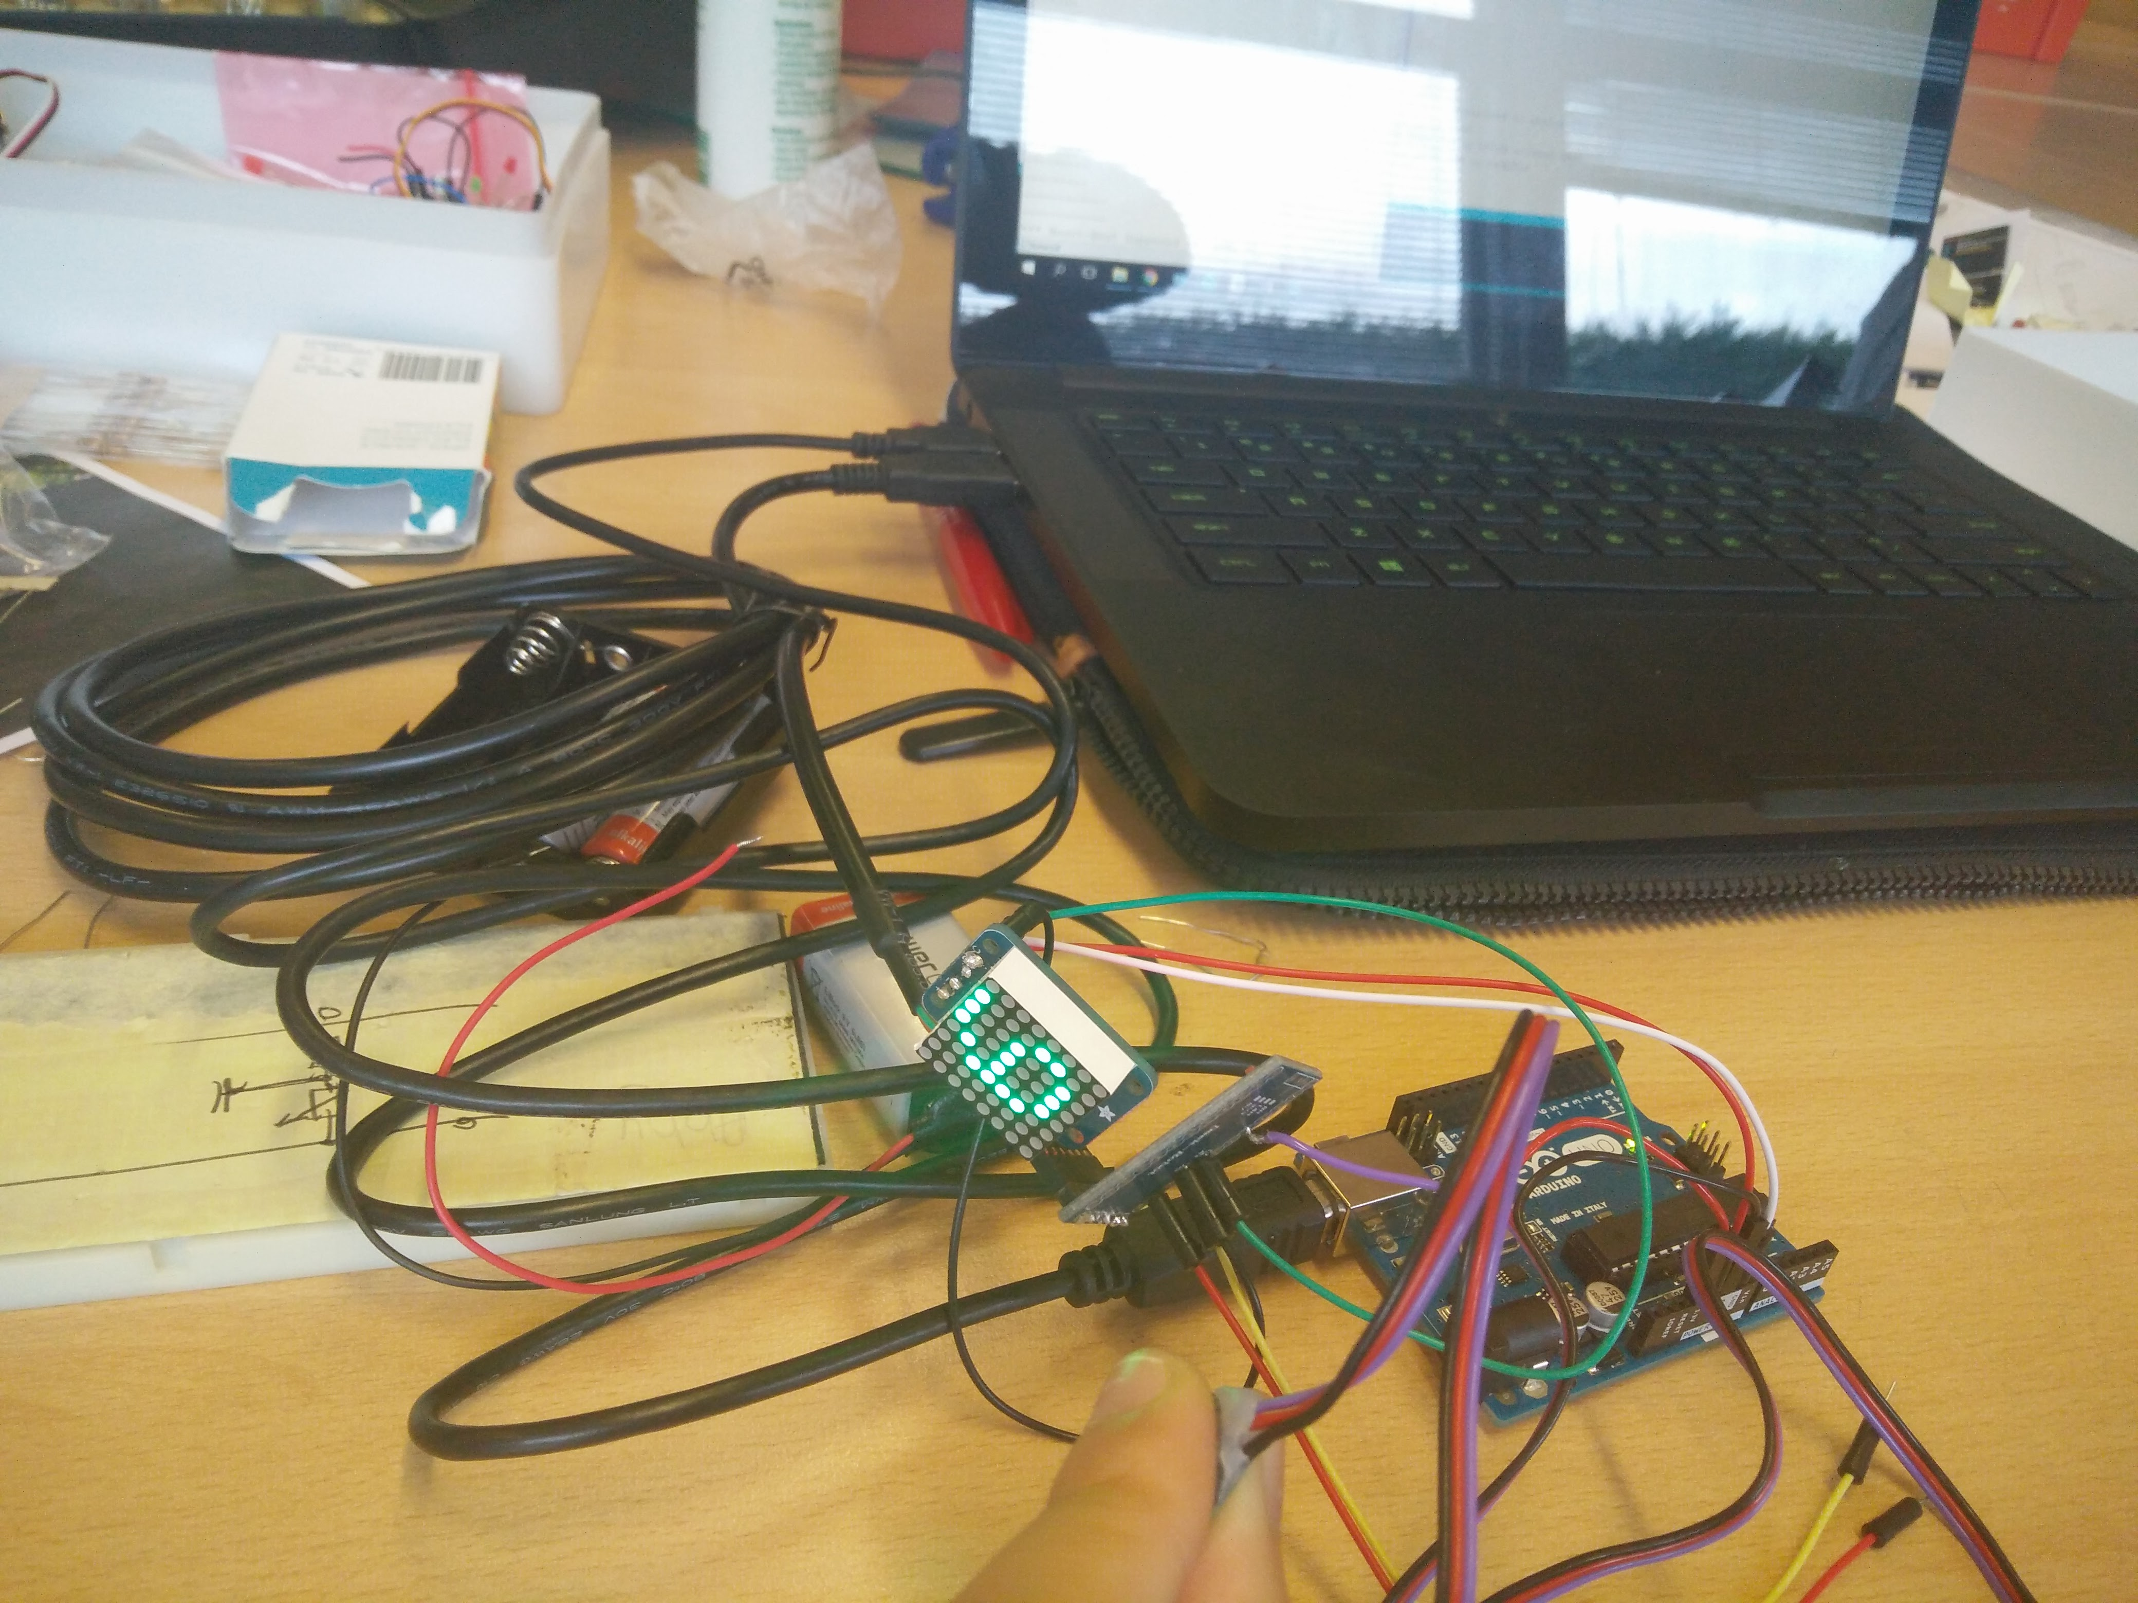Transferring to the Arduino Pro Mini ATMega328, 3.3 V, 8MHz, including soldering and testing out the circuitry:

I plugged it into the computer for the regulated voltage supply, and I used the Arduino uno for the regulated voltage supply for the other two components, the pulse sensor and the LED Matrix. The circuitry worked and everything went exactly as it did with the Arduino Uno. Closer look at the Arduino pro mini:

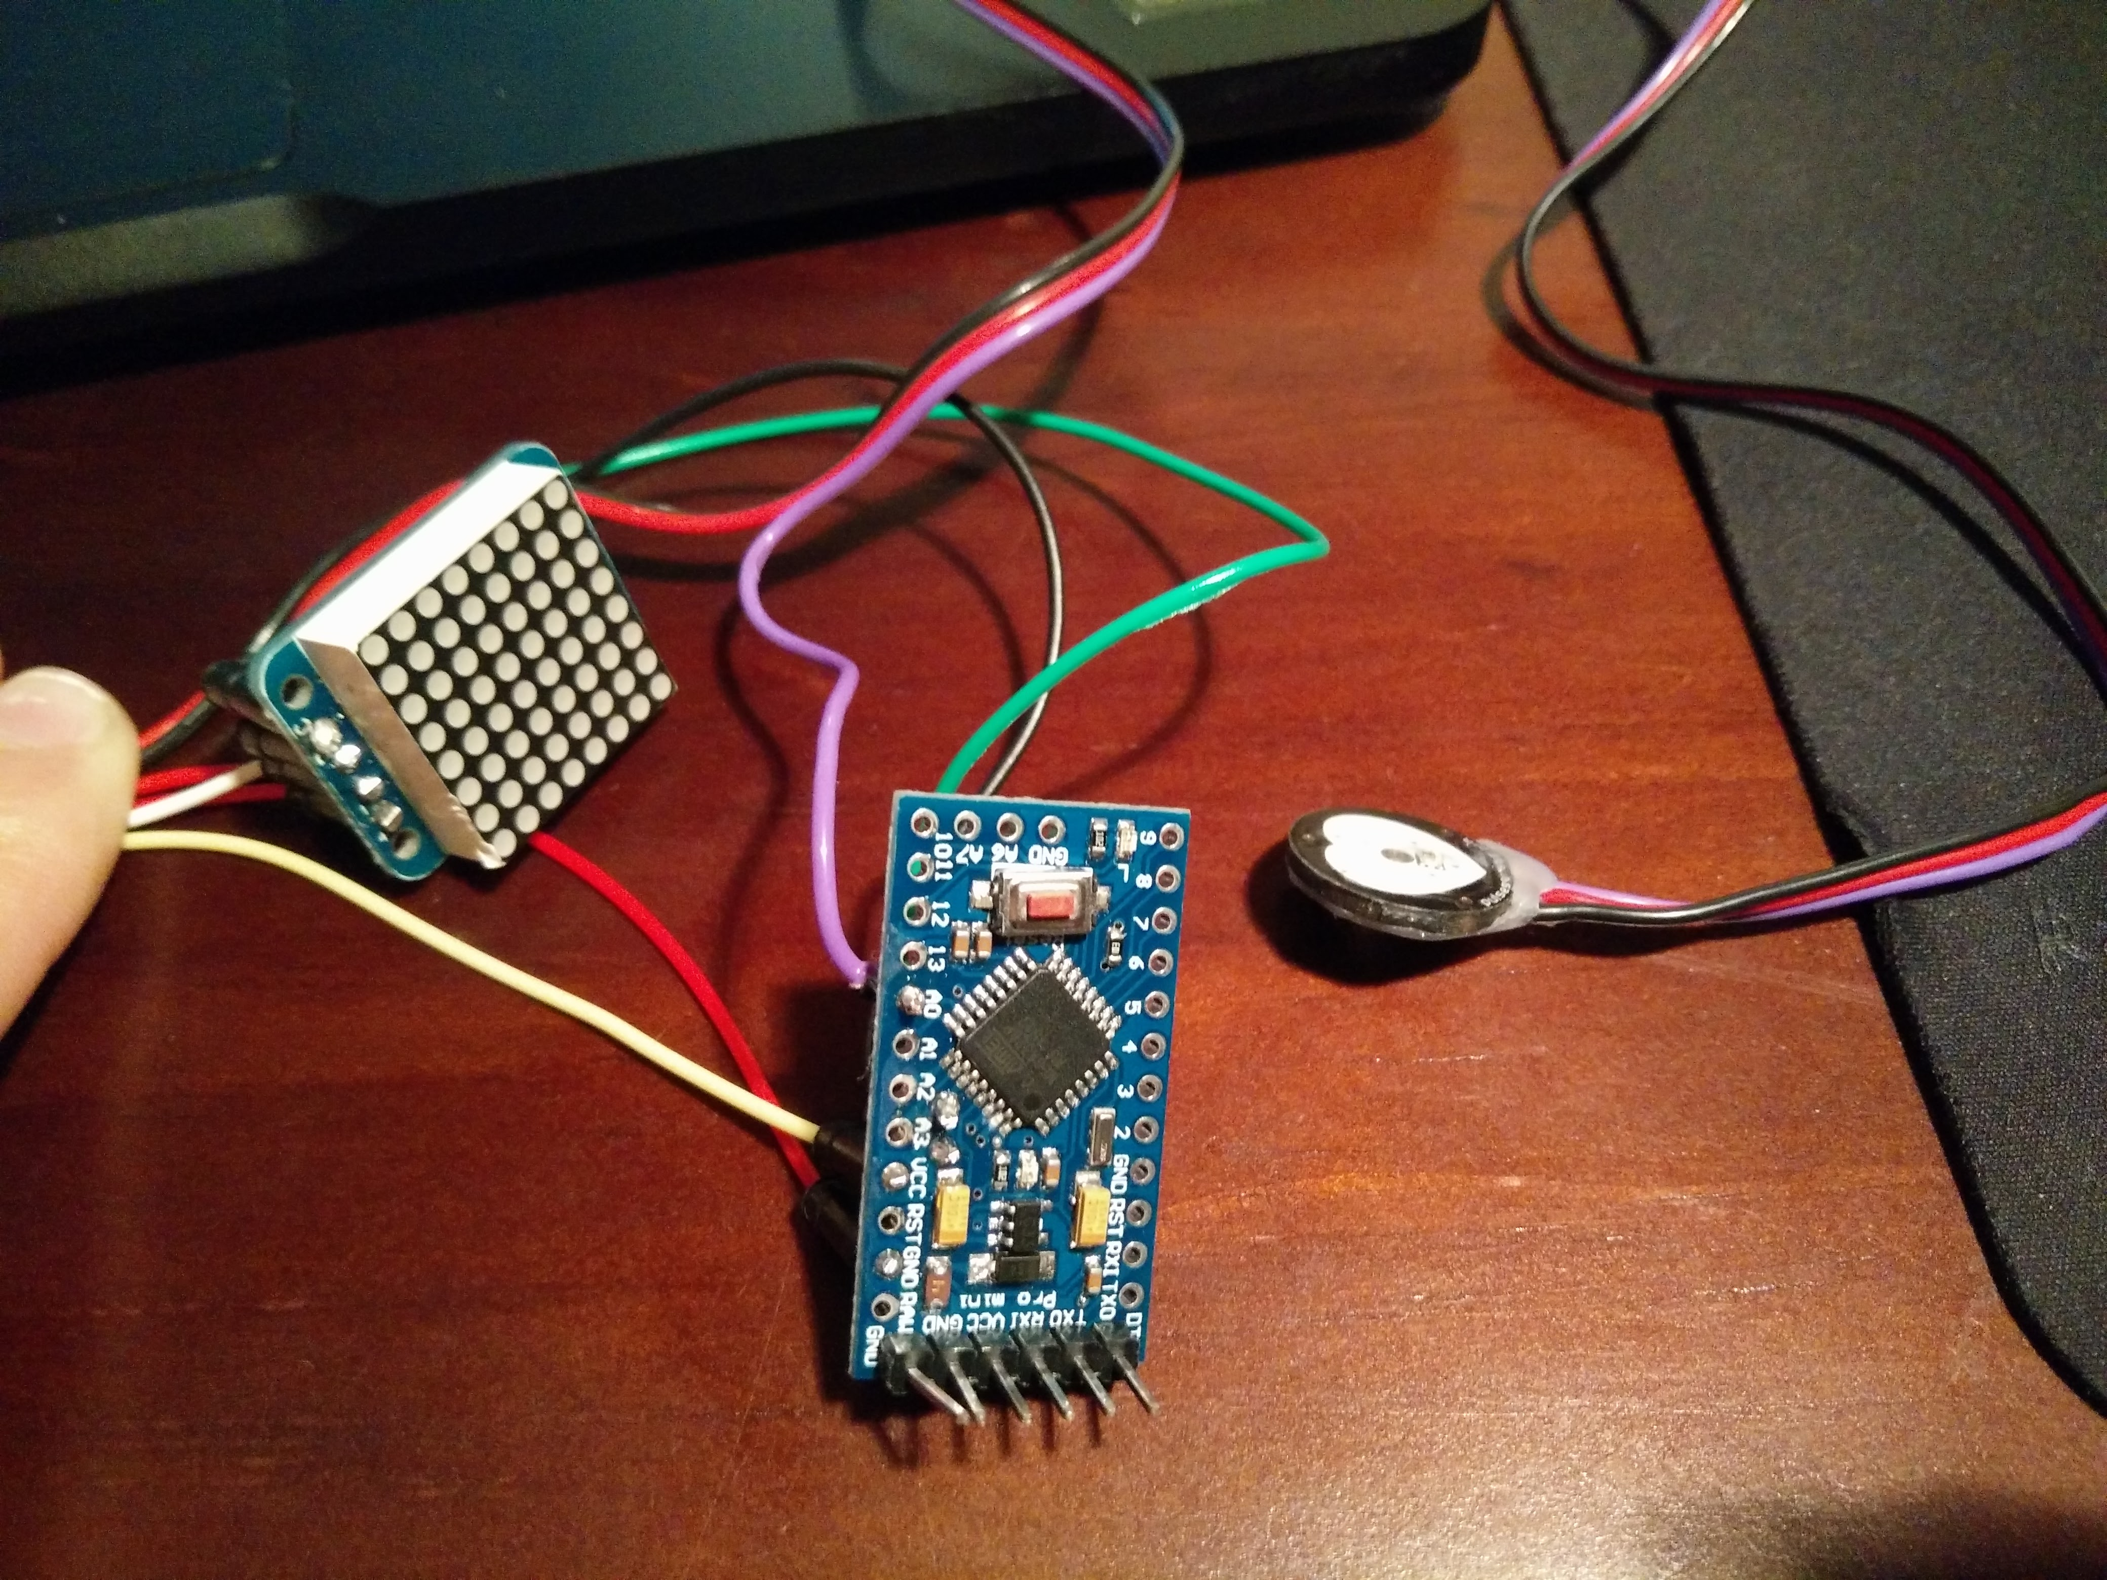

The purple line from the pulse sensor is connected to A0, the black line from SCL (marked C) on the LED Matrix is connected to A5, and the green from SDA (marked D) on the LED Matrix is connected to A4. The other lines are power lines which will be connected with a common negative on a 3V battery.

Battery:

Using tape, due to the lack of time and the lack of a coin cell battery holder, I connected the negative lines with tape to the negative side, and the ones with positive lines with tape to the positive side, taped it in, and used heat-shrink to seal it.

## Casing

I think having a box/enclosure on top of the wrist band will ensure all the components are together in one place. However, the one shown above’s sizes were too small, as it would fit over a wrist but would not fit over the hand before going onto the wrist. It ended up like this:

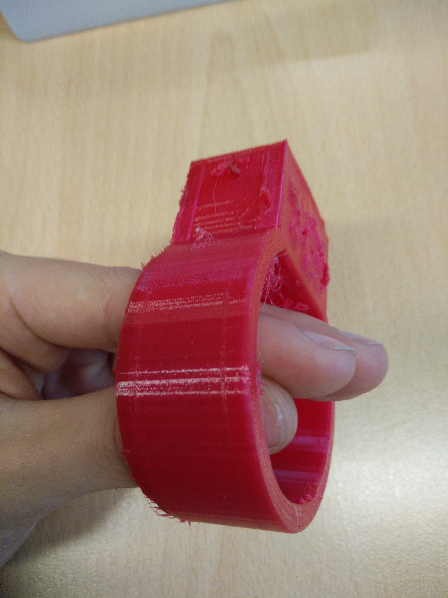Sure it would work for a baby’s hand, but this is for functioning and contributing members of society, such as adults and other children. Not babies. I also could not fit all of the electronic components into the casing, as it was too small. It also did not have a cover on it, so all the components would fall out. So instead, I made another model, with a cover on it so the casing would stay as well. Here it is shown:

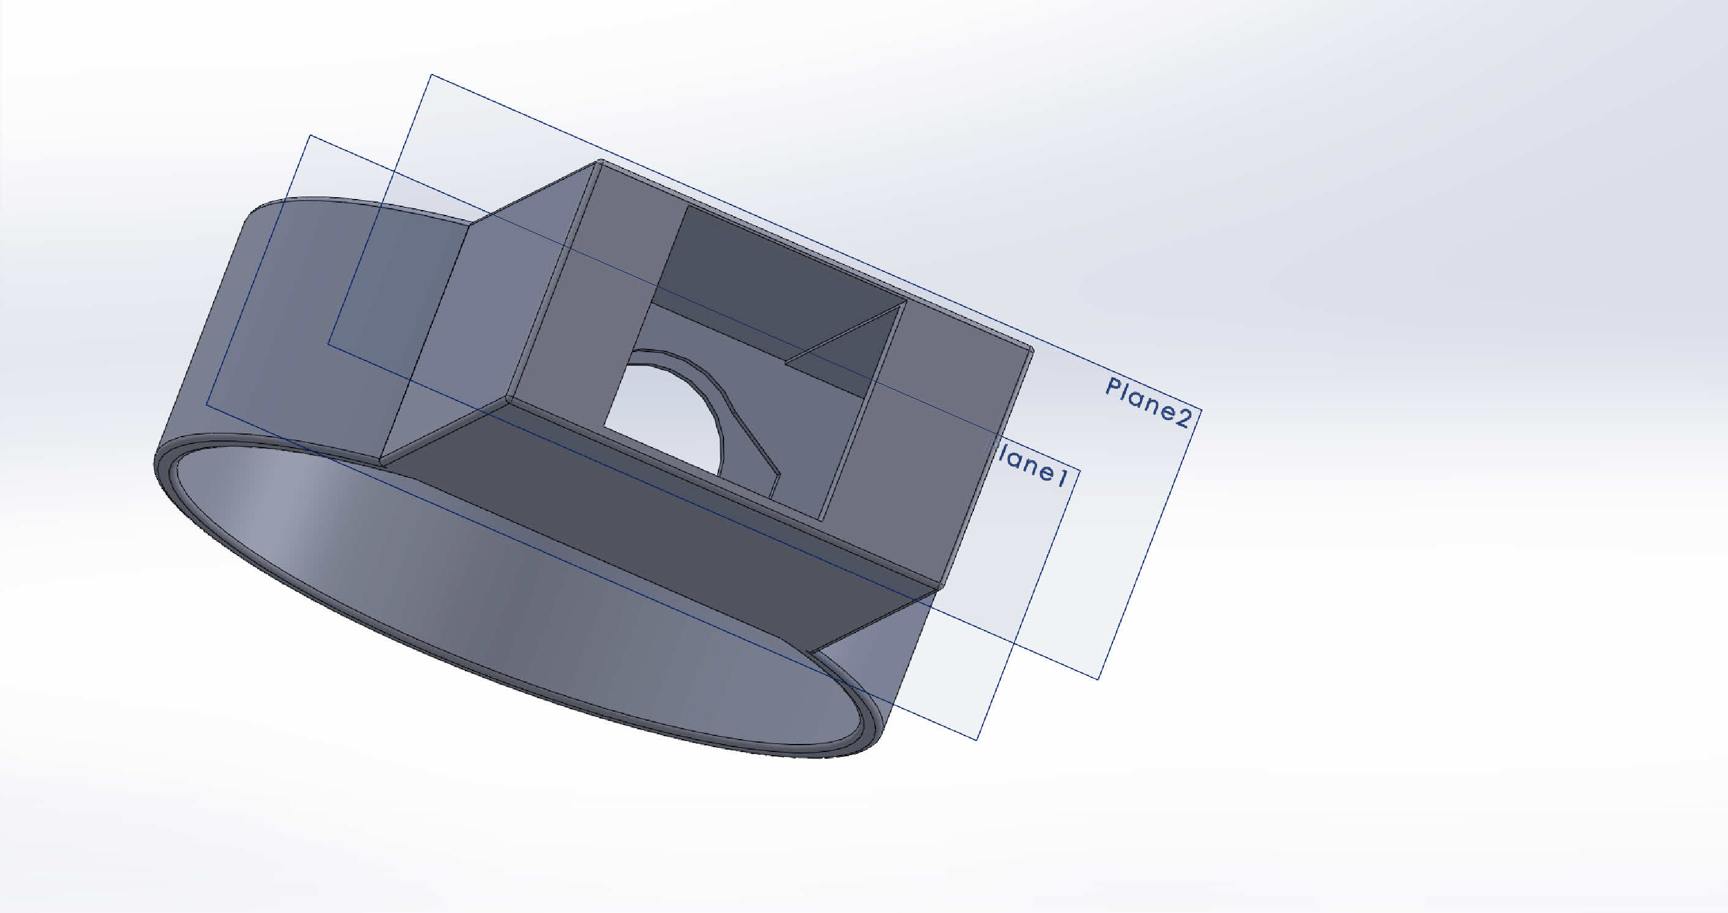

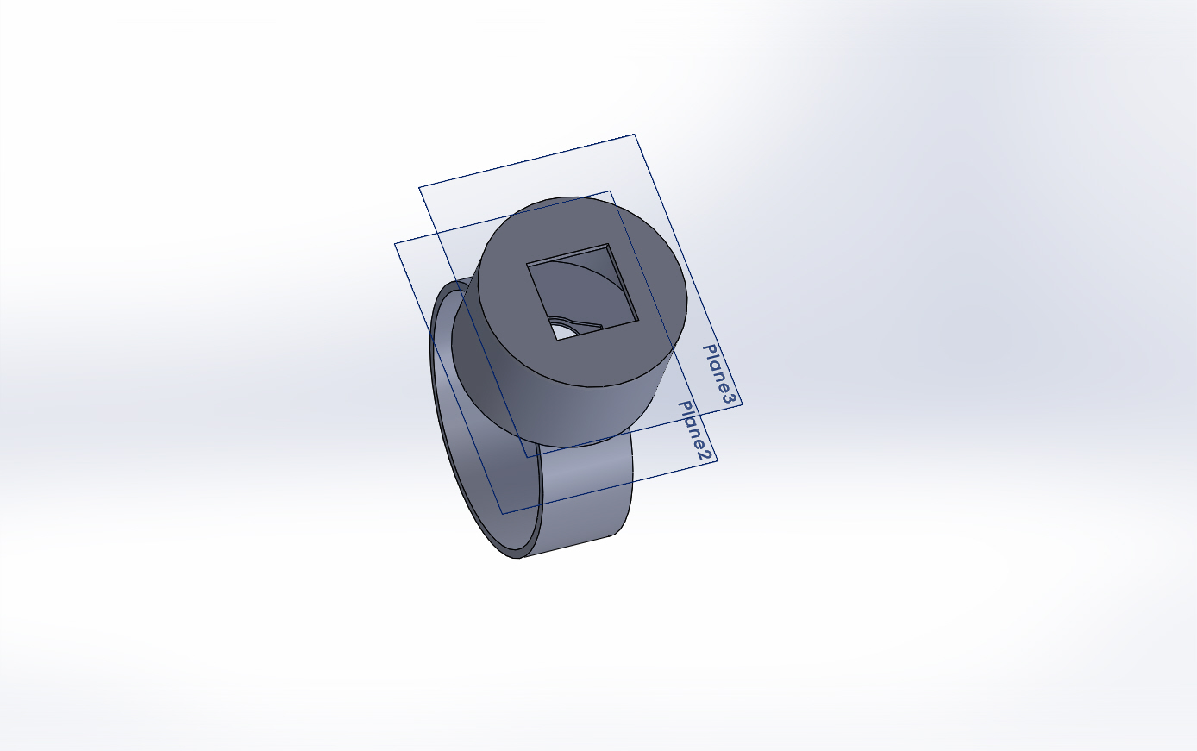I personally figured that the box shape was a little too chunky and not as elegant as the product could be, so in the end I developed this circular product that would not dig in or feel chunky like the other one.

## Risk Assessment

|  |  |  |  |  |
| --- | --- | --- | --- | --- |
| Likelihood/Severity | Unlikely | Possible | Likely | Very Likely |
| Minor Injury | Using a rapid prototyping machine, it is possible for the person to ingest the material and get electrocuted- follow health and safety protocol. | Use of mains electricity might electrocute people, not permitted to use mains electricity. | Use of hot glue guns may burn the user, so keep fingers a safe distance away from it | Use of soldering irons may cause burns to the hands, to prevent this, work carefully.  The use of a nail clipper will probably hurt the fingers, in order to prevent this, hold the centre of the pulse sensor. |

## Production Plan

1. Purchase:
   1. Arduino Pro Mini, ATMega328 chip, running on 3.3V, 8MHz from <https://www.sparkfun.com/products/11114>
   2. Pulse Sensor for Arduino from <https://pulsesensor.com/>
   3. LED Matrix with I2C Backpack, Green from Adafruit <https://www.adafruit.com/products/1633>
   4. 6 Jumper wires, example: [http://proto-pic.co.uk/breadboard-jumper-wire-pack/](http://proto-pic.co.uk/breadboard-jumper-wire-pack/%20%20)
   5. 6 pin header, example: <https://www.sparkfun.com/products/116>
   6. USB to FTDI Basic Cable <https://www.sparkfun.com/products/9717>
   7. Any 3V coin cell battery, example: <http://www.maplin.co.uk/p/lithium-coin-cell-cr2032-3v-battery-1-pack-zb74r>
   8. PVC
   9. Injection Moulder
2. Other materials you will need:
   1. Soldering Iron
   2. Lead free solder
   3. Hot glue gun with hot glue
   4. Small amount of heat-shrink
3. Prepare the pulse sensor
   1. Place a large amount of hot glue on the back of the pulse sensor, and across the 3 wires coming out from it
   2. With a large piece of tape at hand, place the pulse sensor glue side down onto the tape and press gently to squeeze out the excess glue
   3. Once the glue has dried, remove the tape and use a nail clipper to remove the glue around the edges of the pulse sensor
4. Prepare the LED Matrix
   1. Take the I2C backpack, and place the LED Matrix over the silkscreen side, and it is symmetrical so it will go either way.
   2. Turn it over so the LED Matrix is face flat on a surface
   3. Solder all 16 pins in, and cut the long pins.
5. Solder:
   1. A jumper wire from A4 on the Arduino Pro Mini to D on the LED Matrix backpack
   2. A jumper wire from A5 on the Arduino Pro Mini to C on the LED Matrix backpack
   3. The purple line on the pulse sensor to A0 on the Arduino Pro mini
   4. A line from VCC on the Arduino Pro mini
   5. A line from GND on the Arduino Pro mini
   6. A line from + on the LED Matrix
   7. A line from – on the LED Matrix
   8. The headers onto the top end of the Arduino Pro Mini, opposite the reset button
6. Plug the FTDI cable into the headers, and ensure there is a bright red light coming from the Arduino before proceeding
7. Upload the code from [here](#_All_Serial_Handling:)
8. Take the lines and attach them to the battery, with all the lines coming out from the same side
   1. Lines VCC from the Arduino, + from the LED Matrix, and the red one from the pulse sensor should be taped to the positive end of the coin cell battery, ensuring the metal parts of the wires do not touch the negative end
   2. Lines GND from the Arduino, - from the LED Matrix, and the black one from the pulse sensor should be taped to the negative end of the coin cell battery, ensuring the metal parts of the wires do not touch the positive end
   3. Insert the battery into the heat-shrink, ensuring all the wires are facing out from the gap, and use a soldering iron to shrink it so it wraps around the battery and the wires
9. Injection mould the model
10. Place the components into the casing:
    1. Pulse sensor face down into the hole first
    2. Then the Arduino (face up or face down doesn’t matter)
    3. Then the battery component
    4. Then the LED Matrix on screen up

## Circuit Diagram

## Working Drawings

# Evaluation

## Evaluation to Specification

THIS PRODUCT MUST/SHOULD:

1. Be safe for children over the age of 4.
   1. This product achieves this as there are no loose parts in which for children to swallow.
2. Withstand normal bumps and scratches.
   1. This product achieves this as it is made out of PVC (polyvinyl chloride) which is a flexible, durable material.
3. Fit comfortably
   1. This product achieves this as it is ergonomically designed for small wrists, and will come in a range of sizes.
4. Be easy to put on
   1. This product achieves this as it is a plain wristband that contains no extra parts to fasten it in.
5. Be easy to set up/install
   1. This product achieves this as you just have to put it on and it will start working.
6. Cost less than 50 pounds
   1. This product achieves this as all the components needed to produce the product will in total cost less than 50 pounds.
7. Be able to be batch manufactured
   1. This product achieves this as it will be injection moulded meaning it will be able to be batch manufactured.
8. Use a small rechargeable battery
   1. This product does not reach this specification as it actually uses a small coin-cell battery that is not rechargeable but is small, next time I will purchase a rechargeable coin-cell battery.
9. Look fashionable
   1. This product does not achieve this because it is not fashionable to wear but is rather just a box on top of a wristband.
10. Be available in a range of colors
    1. This product achieves this as it will be made out of PVC which comes in a range of colors.
11. Have only one discreet button
    1. This product does not achieve this as it has no buttons at all, however, next time I manufacture this product I will input an on/off button, which is small on the side.
12. Be able to be programmed if needed
    1. This product achieves this as the Arduino pro mini is a programmable and re-programmable device.
13. Must look calming
    1. This product achieves this as it has no sharp edges or provocative shapes in which to upset the user.

## Personal Evaluation

Personally, I believe coding this product and figuring out the code was very stressful, as I was new to C++ and libraries and forums and basically everything Arduino. To encounter such a large project with such huge variables intrigued me, and now that I have finished it, I feel accomplished with what I have done. However, there is still one major part of the string of code that I have not accomplished, which has inhibited the overall quality of the product. In the code, when the Arduino detects a pulse, the code works perfectly fine, but when the Arduino does not detect a pulse, or a pulse does show up and then goes away, the Arduino freezes because it does not know what to do, but I want it to go back to the top of the code. I do not know how to code this and will probably return to forums to teach me how to.

In addition, the use of forums helped me immensely, as I was completely new and so I will definitely return to them to help me.

Some physical aspects of my project that could be improved are taping the wires to the coin cell battery, it isn’t a permanent solution, nor is it very safe, but due to the time constraints, it was all I could do, but in the future, I will get a coin cell battery holder with an on and off switch so it doesn’t go flat.

There was also the use of a hot glue gun for the back of the pulse sensor, which I felt wasn’t very secure or aesthetically pleasing. In the future, I will be designing a cover for the back and to cover the wires so it looks better and feels more secure.

## External Evaluation

Christy’s project is a product that measures one’s pulse from the wrist, and depending if it is too high, it displays a message in the bracelet telling the consumer to breathe in for 4 seconds, hold your breath for 7 seconds and exhale for 8 seconds. Christy has a working circuit that does measure the consumer’s pulse, and when the intervals between heart beats are dangerously high for thirty seconds it tells the person to breathe. Perhaps, the font could be bigger and the colour could be brighter in order for the consumer’s attention to be grabbed otherwise they might not notice the message to breathe. [I believe there should be a few flashes of the screen just to grab the attention, then to have the same level of brightness as it might cause retina burn and hurt the eyes. The font is the biggest it can be for the LED Matrix size.] Also, the battery is stuck on with tape and would be better if it was electronically connected as then it would be better connected and more stable. [I fully agree, it was not done properly and in the future I would use a coin cell battery holder with an on/off switch.]

--Pragna Kasetti

# Appendix

## All Serial Handling

//////////

///////// All Serial Handling Code,

///////// It's Changeable with the 'serialVisual' variable

///////// Set it to 'true' or 'false' when it's declared at start of code.

/////////

void serialOutput() { // Decide How To Output Serial.

if (serialVisual == true){

arduinoSerialMonitorVisual('-', Signal); // goes to function that makes Serial Monitor Visualizer

} else{

sendDataToSerial('S', Signal); // goes to sendDataToSerial function

}

}

// Decides How To OutPut BPM and IBI Data

void serialOutputWhenBeatHappens(){

if (serialVisual == true){ // Code to Make the Serial Monitor Visualizer Work

Serial.print("\*\*\* Heart-Beat Happened \*\*\* "); //ASCII Art Madness

Serial.print("BPM: ");

Serial.print(BPM);

Serial.print(" ");

} else{

sendDataToSerial('B',BPM); // send heart rate with a 'B' prefix

sendDataToSerial('Q',IBI); // send time between beats with a 'Q' prefix

}

}

// Sends Data to Pulse Sensor Processing App, Native Mac App, or Third-party Serial Readers.

void sendDataToSerial(char symbol, int data ){

Serial.print(symbol);

Serial.println(data);

}

// Code to Make the Serial Monitor Visualizer Work

void arduinoSerialMonitorVisual(char symbol, int data ){

const int sensorMin = 0; // sensor minimum, discovered through experiment

const int sensorMax = 1024; // sensor maximum, discovered through experiment

int sensorReading = data;

// map the sensor range to a range of 12 options:

int range = map(sensorReading, sensorMin, sensorMax, 0, 11);

// do something different depending on the

// range value:

switch (range) {

case 0:

Serial.println(""); /////ASCII Art Madness

break;

case 1:

Serial.println("---");

break;

case 2:

Serial.println("------");

break;

case 3:

Serial.println("---------");

break;

case 4:

Serial.println("------------");

break;

case 5:

Serial.println("--------------|-");

break;

case 6:

Serial.println("--------------|---");

break;

case 7:

Serial.println("--------------|-------");

break;

case 8:

Serial.println("--------------|----------");

break;

case 9:

Serial.println("--------------|----------------");

break;

case 10:

Serial.println("--------------|-------------------");

break;

case 11:

Serial.println("--------------|-----------------------");

break;

}

delay(10);

}

## Interrupt Sequence

volatile int rate[10]; // array to hold last ten IBI values

volatile unsigned long sampleCounter = 0; // used to determine pulse timing

volatile unsigned long lastBeatTime = 0; // used to find IBI

volatile int P =512; // used to find peak in pulse wave, seeded

volatile int T = 512; // used to find trough in pulse wave, seeded

volatile int thresh = 525; // used to find instant moment of heart beat, seeded

volatile int amp = 100; // used to hold amplitude of pulse waveform, seeded

volatile boolean firstBeat = true; // used to seed rate array so we startup with reasonable BPM

volatile boolean secondBeat = false; // used to seed rate array so we startup with reasonable BPM

void interruptSetup(){

// Initializes Timer2 to throw an interrupt every 2mS.

TCCR2A = 0x02; // DISABLE PWM ON DIGITAL PINS 3 AND 11, AND GO INTO CTC MODE

TCCR2B = 0x06; // DON'T FORCE COMPARE, 256 PRESCALER

OCR2A = 0X7C; // SET THE TOP OF THE COUNT TO 124 FOR 500Hz SAMPLE RATE

TIMSK2 = 0x02; // ENABLE INTERRUPT ON MATCH BETWEEN TIMER2 AND OCR2A

sei(); // MAKE SURE GLOBAL INTERRUPTS ARE ENABLED

}

// THIS IS THE TIMER 2 INTERRUPT SERVICE ROUTINE.

// Timer 2 makes sure that we take a reading every 2 miliseconds

ISR(TIMER2\_COMPA\_vect){ // triggered when Timer2 counts to 124

cli(); // disable interrupts while we do this

Signal = analogRead(pulsePin); // read the Pulse Sensor

sampleCounter += 2; // keep track of the time in mS with this variable

int N = sampleCounter - lastBeatTime; // monitor the time since the last beat to avoid noise

// find the peak and trough of the pulse wave

if(Signal < thresh && N > (IBI/5)\*3){ // avoid dichrotic noise by waiting 3/5 of last IBI

if (Signal < T){ // T is the trough

T = Signal; // keep track of lowest point in pulse wave

}

}

if(Signal > thresh && Signal > P){ // thresh condition helps avoid noise

P = Signal; // P is the peak

} // keep track of highest point in pulse wave

// NOW IT'S TIME TO LOOK FOR THE HEART BEAT

// signal surges up in value every time there is a pulse

if (N > 250){ // avoid high frequency noise

if ( (Signal > thresh) && (Pulse == false) && (N > (IBI/5)\*3) ){

Pulse = true; // set the Pulse flag when we think there is a pulse

// digitalWrite(blinkPin,HIGH); // turn on pin 13 LED

IBI = sampleCounter - lastBeatTime; // measure time between beats in mS

lastBeatTime = sampleCounter; // keep track of time for next pulse

if(secondBeat){ // if this is the second beat, if secondBeat == TRUE

secondBeat = false; // clear secondBeat flag

for(int i=0; i<=9; i++){ // seed the running total to get a realisitic BPM at startup

rate[i] = IBI;

}

}

if(firstBeat){ // if it's the first time we found a beat, if firstBeat == TRUE

firstBeat = false; // clear firstBeat flag

secondBeat = true; // set the second beat flag

sei(); // enable interrupts again

return; // IBI value is unreliable so discard it

}

// keep a running total of the last 10 IBI values

word runningTotal = 0; // clear the runningTotal variable

for(int i=0; i<=8; i++){ // shift data in the rate array

rate[i] = rate[i+1]; // and drop the oldest IBI value

runningTotal += rate[i]; // add up the 9 oldest IBI values

}

PBI = rate[8];

rate[9] = IBI; // add the latest IBI to the rate array

runningTotal += rate[9]; // add the latest IBI to runningTotal

runningTotal /= 10; // average the last 10 IBI values

BPM = 60000/runningTotal; // how many beats can fit into a minute? that's BPM!

QS = true; // set Quantified Self flag

// QS FLAG IS NOT CLEARED INSIDE THIS ISR

// QS FLAG IS NOT CLEARED INSIDE THIS ISR

}

}

if (Signal < thresh && Pulse == true){ // when the values are going down, the beat is over

// digitalWrite(blinkPin,LOW); // turn off pin 13 LED

Pulse = false; // reset the Pulse flag so we can do it again

amp = P - T; // get amplitude of the pulse wave

thresh = amp/2 + T; // set thresh at 50% of the amplitude

P = thresh; // reset these for next time

T = thresh;

}

if (N > 2500){ // if 2.5 seconds go by without a beat

thresh = 512; // set thresh default

P = 512; // set P default

T = 512; // set T default

lastBeatTime = sampleCounter; // bring the lastBeatTime up to date

firstBeat = true; // set these to avoid noise

secondBeat = false; // when we get the heartbeat back

}

sei(); // enable interrupts when youre done!

}// end isr

## Main Code

/\* Pulse Sensor Amped 1.4 by Joel Murphy and Yury Gitman http://www.pulsesensor.com

---------------------- Notes ---------------------- ----------------------

This code:

1) Blinks an LED to User's Live Heartbeat PIN 13

2) Fades an LED to User's Live HeartBeat

3) Determines BPM

4) Prints All of the Above to Serial

Read Me:

https://github.com/WorldFamousElectronics/PulseSensor\_Amped\_Arduino/blob/master/README.md

---------------------- ---------------------- ----------------------

\*/

#include <Wire.h>

#include "Adafruit\_LEDBackpack.h"

#include "Adafruit\_GFX.h"

Adafruit\_8x8matrix matrix = Adafruit\_8x8matrix();

// Variables

int pulsePin = 0; // Pulse Sensor purple wire connected to analog pin 0

int blinkPin = 13; // pin to blink led at each beat

int fadePin = 5; // pin to do fancy classy fading blink at each beat

int fadeRate = 0; // used to fade LED on with PWM on fadePin

int EmoLite = 12;

// Volatile Variables, used in the interrupt service routine!

volatile int BPM; // int that holds raw Analog in 0. updated every 2mS

volatile int Signal; // holds the incoming raw data

volatile int IBI = 600; // int that holds the time interval between beats! Must be seeded!

volatile int PBI = 600; // PBI stands for Previous Beat Interval, assigned at the same at as rate[8]

volatile boolean Pulse = false; // "True" when User's live heartbeat is detected. "False" when not a "live beat".

volatile boolean QS = false; // becomes true when Arduoino finds a beat.

// Regards Serial OutPut -- Set This Up to your needs

static boolean serialVisual = true; // Set to 'false' by Default. Re-set to 'true' to see Arduino Serial Monitor ASCII Visual Pulse

void setup() {

interruptSetup(); // sets up to read Pulse Sensor signal every 2mS

// IF YOU ARE POWERING The Pulse Sensor AT VOLTAGE LESS THAN THE BOARD VOLTAGE,

// UN-COMMENT THE NEXT LINE AND APPLY THAT VOLTAGE TO THE A-REF PIN

// analogReference(EXTERNAL);

matrix.begin(0x70); // pass in the address

pinMode(EmoLite, OUTPUT);

Serial.begin(57600); // we agree to talk fast!

interruptSetup(); // sets up to read Pulse Sensor signal every 2mS

}

static const uint8\_t PROGMEM

smile\_bmp[] =

{ B00111100,

B01000010,

B10100101,

B10000001,

B10100101,

B10011001,

B01000010,

B00111100

},

neutral\_bmp[] =

{ B00111100,

B01000010,

B10100101,

B10000001,

B10111101,

B10000001,

B01000010,

B00111100

},

frown\_bmp[] =

{ B00111100,

B01000010,

B10100101,

B10000001,

B10011001,

B10100101,

B01000010,

B00111100

};

// Where the Magic Happens

void loop() {

matrix.clear();

serialOutput() ;

if (QS == true) { // A Heartbeat Was Found

// BPM and IBI have been Determined

// Quantified Self "QS" true when arduino finds a heartbeat

serialOutputWhenBeatHappens(); // A Beat Happened, Output that to serial.

QS = false; // reset the Quantified Self flag for next time

//insert something so when you don't find a pulse, it loops back to the beginning......... MAKE IT WORK

if (IBI - PBI <= -90) { //when the difference between the most recent IBI and the one before IBI is less than -90

delay(1000);

if (IBI - PBI <= -90) {

delay(1000);

if (IBI - PBI <= -90) {

digitalWrite(EmoLite, HIGH);

matrix.setBrightness(3);

matrix.setTextSize(1);

matrix.setTextWrap(false); // we dont want text to wrap so it scrolls nicely

matrix.setTextColor(LED\_ON);

for (int8\_t x = 0; x >= -45; x--) {

matrix.clear();

matrix.setCursor(x, 0);

matrix.print("In 2 3 4");

matrix.writeDisplay();

delay(100);

}

for (int8\_t x = 9; x >= -90; x--) {

matrix.clear();

matrix.setCursor(x, 0);

matrix.print("Hold 2 3 4 5 6 7");

matrix.writeDisplay();

delay(100);

}

for (int8\_t x = 16; x >= -103; x--) {

matrix.clear();

matrix.setCursor(x, 0);

matrix.print("Out 2 3 4 5 6 7 8");

matrix.writeDisplay();

delay(100);

}

matrix.setRotation(0);

delay(100000);

}

else {

digitalWrite(EmoLite, LOW);

matrix.clear();

}

}

else {

digitalWrite(EmoLite, LOW);

matrix.clear();

}

}

else {

digitalWrite(EmoLite, LOW);

matrix.clear();

}

// QS FLAG IS NOT CLEARED INSIDE THIS ISR

}

}

1. <http://www.who.int/gho/ncd/risk_factors/blood_pressure_prevalence_text/en/> Accessed on 15.1.15. [↑](#footnote-ref-2)
2. <http://www.cdc.gov/bloodpressure/facts.htm> Accessed on 14.1.15. [↑](#footnote-ref-3)
3. <http://www.cdc.gov/bloodpressure/facts.htm> Accessed on 14.1.15. [↑](#footnote-ref-4)
4. <http://www.strokeassociation.org/STROKEORG/> Accessed on 14.1.15. [↑](#footnote-ref-5)
5. <http://www.heart.org/HEARTORG/> Accessed on 14.1.15. [↑](#footnote-ref-6)
6. Dr. Christie Chan-Metcalfe, Hong Kong Southside Health Center. [↑](#footnote-ref-7)
7. <https://www.bhf.org.uk/heart-health/conditions> Accessed on 15.1.15. [↑](#footnote-ref-8)
8. <http://psychcentral.com/lib/how-does-stress-affect-us/> Accessed on 2.10.15. [↑](#footnote-ref-9)
9. <http://www.mybasis.com/en-GB/blog/2013/10/the-science-of-stress-heart-rate-and-breathing/> Accessed on 2.10.15. [↑](#footnote-ref-10)
10. <http://www.wamda.com/application/rapyd/assets/mfm_012/upload/heart_rate.png> Accessed on 2.10.15. [↑](#footnote-ref-11)
11. Healing without Freud or Prozac: Natural approaches to curing stress, anxiety, and depression By David Servan-Schreiber [↑](#footnote-ref-12)
12. <http://www.webmd.com/asthma/guide/hypoxia-hypoxemia> Accessed on 15.1.15. [↑](#footnote-ref-13)
13. <http://helivac.co.za/2013/11/15/strokes/> Accessed on 15.1.15. [↑](#footnote-ref-14)
14. <http://www.vivomed.com/en/Polar-FT2/m-8221.aspx?gclid=CKK4mMeDzcMCFcjHtAodCkwA5g&utm_source=google&utm_medium=shopping&utm_campaign=UnitedKingdom> [↑](#footnote-ref-15)
15. <http://www.vivomed.com/en/Polar-FT4/m-7696.aspx> [↑](#footnote-ref-16)
16. <http://www.technologyreview.com/news/424539/a-wristwatch-that-monitors-blood-pressure/> [↑](#footnote-ref-17)
17. [http://www.beliefnet.com/Wellness/Health/2006/03/Dont-Be-Alarmed.aspx?p=2#](http://www.beliefnet.com/Wellness/Health/2006/03/Dont-Be-Alarmed.aspx?p=2) [↑](#footnote-ref-18)
18. <http://www.rei.com/learn/expert-advice/batteries.html> [↑](#footnote-ref-19)
19. <http://www.powerstream.com/NiMH.htm> Accessed on 5.3.2015. [↑](#footnote-ref-20)
20. <http://www.bloodpressureuk.org/microsites/kyn/Home/Media/Factsandfigures> Accessed on 5.3.2015. [↑](#footnote-ref-21)
21. <http://www.polar.com/uk-en/products/get_active/fitness_crosstraining/FT2> [↑](#footnote-ref-22)
22. <http://www.fitnessdigital.co.uk/garmin-heart-rate-monitor/p/10002864/?ct=108&gclid=CMy8nreVm8QCFUHlwgodkpEA_g> [↑](#footnote-ref-23)
23. <http://www.primarycaresupplies.co.uk/products/Medical+Equipment+%26+Diagnostics/Blood+Pressure+%26+ABPM/Digital+Blood+Pressure+Monitors/Omron+RS2+Wrist+Blood+Pressure+Monitor/2373413690?gclid=CNOPmr-Wm8QCFWL3wgodc6AAUQ> [↑](#footnote-ref-24)
24. <https://www.google.co.uk/shopping/product/12325464710559627085?q=blood%20pressure%20monitor%20wrist&espv=2&biw=1920&bih=979&bav=on.2,or.&bvm=bv.87611401,d.d2s&ion=1&tch=1&ech=1&psi=aoj9VMmANIP8aLnqgYgB.1425901675426.5&safe=active&ssui=on&ei=eYj9VLylK9GVatGQgcAF&ved=0CJUBEKYrMAE&prds=hsec:online> Accessed on 16.03.15. [↑](#footnote-ref-25)
25. <http://www.wms.co.uk/Ambulatory_Blood_Pressure_Monitoring/BPro_Wrist_Ambulatory_Blood_Presure_Monitor/BPro_Wrist_Ambulatory_Blood_Presure_Monitor?gclid=CMTe8_Gam8QCFQTJtAoda1YAdQ> Accessed on 16.03.15 [↑](#footnote-ref-26)
26. <https://www.google.co.uk/shopping/product/14663058897349108002?biw=1920&bih=979&q=wrist+blood+pressure+monitor&bav=on.2,or.&ion=1&espv=2&tch=1&ech=1&psi=qIn9VN2AB8PkaoOPgpAM.1425902337515.5&safe=active&ssui=on&ei=D4v9VMH6Itbfarz4gHA&ved=0CGwQpiswAA> Accessed on 16.03.15. [↑](#footnote-ref-27)
27. <http://www.onceuponaname.com/sizing.html> Accessed on 18.03.15. [↑](#footnote-ref-28)
28. <http://usability.gtri.gatech.edu/eou_info/hand_anthro.php> Accessed on 18.03.15. [↑](#footnote-ref-29)
29. <http://www.colour-affects.co.uk/psychological-properties-of-colours> Accessed on 18.03.15. [↑](#footnote-ref-30)
30. <http://www.intechopen.com/source/html/16435/media/image6.jpeg> Image accessed on 21.9.15. [↑](#footnote-ref-31)
31. <http://www.diabetesmonitor.com/glucose-meters/what-happened-to-the-glucowatch.htm> Accessed on 21.9.15. [↑](#footnote-ref-32)
32. Sevenoaks Technology App by Mr. Lawrie. Accessed on 23.2.16. [↑](#footnote-ref-33)
33. <http://pulsesensor.com/> Accessed on 23.2.16. [↑](#footnote-ref-34)
34. <http://arduino.cc/> Accessed on 23.2.16. [↑](#footnote-ref-35)
35. Sevenoaks Technology App by Mr. Lawrie Accessed on 23.2.16. [↑](#footnote-ref-36)
36. Picture of capacitive touch sensor from <https://www.adafruit.com/images/1200x900/1374-00.jpg> Accessed on 14.9.15 [↑](#footnote-ref-37)
37. Picture of USB wristband. <http://www.usb-wristbands.com/images/slap-on-usb-wristbands.png> Accessed on 15.9.15. [↑](#footnote-ref-38)
38. Picture of LED watch. <http://goo.gl/l3Nptq> Accessed on 15.9.15. [↑](#footnote-ref-39)
39. Picture of sweatband. <https://www.whitbypandemonium.co.uk/images/Sweatband-Red-black.jpg> Accessed on 15.9.15. [↑](#footnote-ref-40)
40. Picture of LCD screens taken from <http://i01.i.aliimg.com/img/pb/443/783/467/467783443_122.jpg> Accessed on 16.9.15. [↑](#footnote-ref-41)
41. <http://www.totalwatchrepair.com/sc_images/products/1041_image.jpg> Picture of watch strap. Accessed on 18.9.15. [↑](#footnote-ref-42)
42. <http://timerecs.com/imgs/a/a/a/w/s/casio_men_g___shock_ga___100b___7ajf_wrist_watch_white_japan_1_thumb2_lgw.jpg> Picture of watch. Accessed on 14.9.15.

    <http://www.marcresearch.com/blogs/merrill/2015/05/27/thumbs-up-or-thumbs-down-time-to-take-a-fun-quiz-and-let-me-know/> Thumbs down picture. Accessed on 14.9.15. [↑](#footnote-ref-43)
43. <http://speckycdn.sdm.netdna-cdn.com/wp-content/uploads/2011/07/08-iphone-app-graph.jpg> Picture of graph, accessed on 18.9.15. [↑](#footnote-ref-44)
44. <http://www.healthandcare.co.uk/user/products/large/McDavidElasticWristSupport.jpg> Picture of velcro wrist support, accessed on 18.9.15. [↑](#footnote-ref-45)
45. <http://image4.spreadshirtmedia.com/image-server/v1/products/108293870/views/1,width=378,height=378,appearanceId=70/Plain-Heart-Phone---Tablet-Cases.png> Picture of phone case. Accessed on 14.9.15

    <http://g03.a.alicdn.com/kf/HTB1nRbHIpXXXXbJXpXXq6xXFXXXU/Unisex-Cotton-Gym-Sport-Wrist-Support-Wraps-Crossfit-Vendas-Para-Deporte-Sweatband-Wrist-Guards-Hand-Wraps.jpg> Picture of wristband, accessed on 14.9.15 [↑](#footnote-ref-46)
46. <http://www.apple.com/shop/watch/sizing-guide> Accessed on 30.9.15. [↑](#footnote-ref-47)
47. Dr. Lindsay Gorrill, 7.12.15. [↑](#footnote-ref-48)